|  |
| --- |
| A Fair and Responsive Public Service for All |
|  |
| Independent Review of Queensland public employment law |
|  |
| Issues Paper  December 2018 |

**Copyright**

This publication is protected by the Copyright Act 1968. © State of Queensland, December 2018.

**Licence**

This work is licensed by the Department of the Premier and Cabinet under a Creative Commons Attribution (CC BY) 4.0 International licence. To view a copy of this licence, visit: <https://creativecommons.org/licenses/by/4.0/>

You are free to copy, communicate and adapt this publication, as long as you attribute appropriately, including:

* The name of the publication “A fair and responsive public service for all – independent Review of Queensland public employment law: issues paper”
* A link to the work if you have sourced it online
* The copyright licence statement above
* Indicate if you have made changes to the work.

**Abbreviations used in this paper**

|  |  |
| --- | --- |
| CE; CEO | Chief Executive; Chief Executive Officer |
| DAF | Department of Agriculture and Fisheries |
| DATSIP | Department of Aboriginal and Torres Strait Islander Partnerships |
| DCDSS | Department of Communities, Disability Services and Seniors |
| DCSYW | Department of Child Safety, Youth and Women |
| DES | Department of Environment and Science |
| DESBT | Department of Employment, Small Business and Training |
| DG | Director-General |
| DHPW | Department of Housing and Public Works |
| DITICG | Department of Innovation, Tourism Industry Development and the Commonwealth Games |
| DJAG | Department of Justice and Attorney-General |
| DLGRMA | Department of Local Government, Racing and Multicultural Affairs |
| DNRME | Department of Natural Resources, Mines and Energy |
| DoE | Department of Education |
| DPC | Department of the Premier and Cabinet |
| DSDMIP | Department of State Development, Manufacturing, Infrastructure and Planning |
| DTMR | Department of Transport and Main Roads |
| EEO | Equality of employment opportunity |
| FTE | full-time equivalent (employee) |
| HHS | Hospital and Health Service |
| HR; HRM | human resource(s); human resource management |
| IME | independent medical examination |
| MoG | machinery of government |
| PSBA | Public Safety Business Agency |
| PSC | Public Service Commission |
| PSMC | Public Sector Management Commission (1990–1996) |
| QCS | Queensland Corrective Services |
| QFES | Queensland Fire and Emergency Services |
| QH | Queensland Health |
| QIRC | Queensland Industrial Relations Commission |
| QPS | Queensland Police Service |
| QT | Queensland Treasury |
| SES | Senior Executive Service |
| SO | Senior Officer |

**CONTENTS**

Overview 6

Terms of Reference 6

Consultation Questions 9

PART 1 The review of public employment laws 11

1 The review: A Fair and Responsive Public Service for All 12

1.1 Consultation on terms of reference and issues 12

1.2 Notes on exclusions 12

PART 2 ISSUES 16

2 Why a review? 17

2.1 Employment 17

2.2 Discipline and performance 20

2.3 A new Act? 24

2.4 More about employment 24

2.5 The value of public services 26

2.6 Merit and diversity 34

2.7 Equal opportunity; Gender pay equity 35

2.8 Organising government 40

2.9 Rights and responsibilities 43

2.10 Before employment 43

2.11 Management and administration 45

2.12 Public sector ethics 56

3 Other stakeholder input 58

4 Attachments 60

4.1 Public employment pathways 60

*4.2* Provisions of *Public Service Regulation 2018* 65

4.3 Type of appointment 66

4.4 Queensland public sector agencies 74

4.5 Public service offices 75

4.6 Departments and agencies in other States and Territories 77

4.7 Central human resource agencies 81

4.8 Merit in public employment Acts 90

*4.9* *Public Sector Ethics Act 1994* 92

Figure 1: Fair, Responsive and Inclusive 13

Figure 2: Responsive to Community and to Government 14

Figure 3: Coverage of the Public Service Act 2008 (a rough guide) 23

Figure 4 Three role types of public employees 29

Figure 5: Appointment type by department, June 2018 (Queensland public service workforce statistics) 31

Figure 6: The Queensland public health system 42

Figure 7: Management under the Public Service Act 2008 47

# Overview

This is a review of legislation governing public employment – primarily the *Public Service Act 2008* but also other Acts dealing with employment, such as the *Hospital and Health Boards Act 2011*. There are more than 90 such Acts in Queensland.

Public employment is a complicated area of law, beset by technicality, but important because these laws govern the employment of some 250,000 people and the services received by five million Queenslanders, businesses and the community.

In reviewing the Acts and talking to stakeholders, it is clear the *Public Service Act 2008* is generally seen as not “fit for purpose”*.* For a fair and inclusive public service, responsive to community and government, the Act needs to be changed.

This review represents an opportunity to craft new Queensland public employment laws that are meaningful to employees, government and community alike; laws that are nuanced and not just managerial or administrative but enabling and empowering as well as coherent and efficient.

Many of the issues raised by stakeholders are about behaviour and culture, things not easy to legislate for. But an Act can create institutions, mandate processes, allocate responsibility, and provide signposts and rules that lead towards change.

This issues paper is an opportunity for those interested in public employment to chart the direction for a new set of laws for *a fair and responsive public service for all*.

While there are specific questions raised in this paper, input is not restricted to those questions. All comments and suggestions are welcome.

A final report is scheduled for late March 2019.

Input is invited by close of business 25 January 2019. Contributions can be sent via [psareview@psareview.qld.gov.au](mailto:psareview@psareview.qld.gov.au)

Peter Bridgman

BA (Hons) LLB (Hons) FIML

Barrister-at-Law

Independent Reviewer

# Terms of Reference

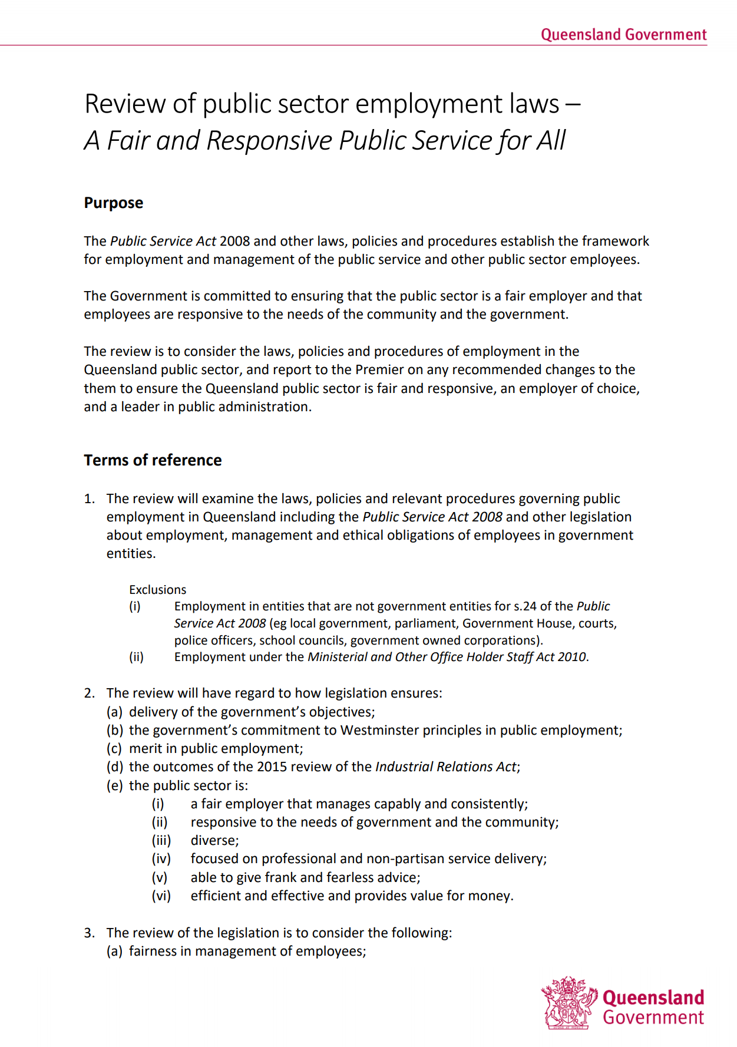

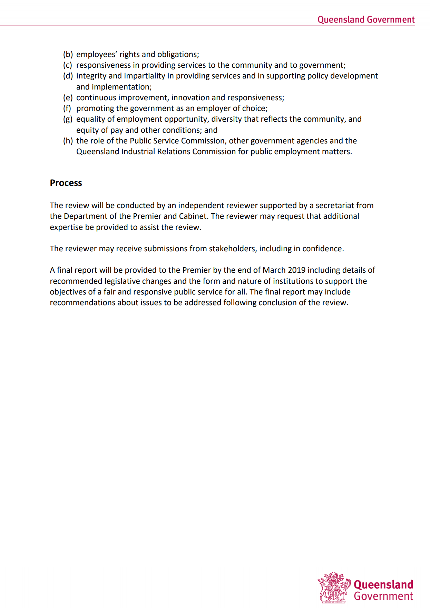

# Consultation Questions

|  |
| --- |
| 1. The review will address the employment relationship and how it can be made more transparent. Comment is invited on this issue. 2. What can be done to improve first line management skills so that performance and conduct issues are addressed early and effectively? 3. What would ensure performance improvement is adequately differentiated from disciplinary proceedings? 4. How can risk assessment be used to facilitate early resolution? 5. What processes would improve the support given to the chief executive in managing discipline and improving performance? 6. The Act requires management to work towards the public service being an employer of choice. Input is invited on how the Act can facilitate this? 7. Can the temporary and casual conversion provisions, and the review of related decisions, be improved? 8. Is the category of general employee useful? What are the implications if general employees are treated the same as other public service employees? 9. What criteria should apply to a decision that an individual employee is redundant, or that there are more employees than necessary in a department or other entity? 10. Are there any comments on the terms of employment for other types of employee (for example, contract including executive contracts), or about redundancy? 11. Are changes needed to make the merit principle work better in practice? 12. How can the merit principle better align with other objectives such as diversity, inclusivity and belonging? 13. What is the role of the central personnel agency in protecting the merit principle? 14. What process should be used for formal merit protection action? 15. What improvements can be made to enhance the equal employment opportunity processes and obligations? 16. How should the Public Service Act address gender pay equity issues? 17. Can the suspension provisions be improved to be made fairer and more efficient to administer? 18. What factors should guide a decision to outsource investigations? 19. Should there be prescribed limits on the role of external investigators? Is the ‘support’ role in investigations and disciplinary processes useful to ensure fairness? 20. Are there circumstances when an employee should be entitled to representation in investigation and disciplinary meetings? 21. What circumstances warrant an independent medical examination? 22. What should the rights of an employee be if required to undergo an independent medical examination? 23. How can machinery of government changes be made to work better? 24. How should change arising from machinery of government and policy change be managed? 25. Should a central agency retain power to undertake formal reviews and make reports about agencies? In what circumstances? 26. Are there other ways to systematically ensure continuous improvement and critical examination of agency operations? 27. How should consistency within and between services, departments and agencies be achieved? 28. How might services be organised to ensure coherent and integrated management? 29. How should the Act provide for and articulate rights and responsibilities? 30. Should the current citizenship requirement be retained? 31. Could the processes under the *Public Service Act 2008* for blue card and criminal history checks be improved? 32. Are there alternatives to gazette publication that ensure transparency and a proper record? 33. How can the Public Service Act facilitate employee access to relevant policies? 34. How can the Public Service Act facilitate a streamlined process that supports, nurtures and promotes existing talent while maintaining fair and open merit-based recruitment? 35. Does section 26 of the Public Service Act adequately express the responsibilities of employees and their managers? 36. Could these responsibilities be framed more positively? 37. How should the senior executive and section 122 cohorts be administered? 38. What can be done to improve executive mobility and development of a stronger service-wide perspective among executives? 39. Should the Senior Officer position be retained? If not, what changes should be made to ensure fairness to exiting Senior Offices? 40. Are there mechanisms that can improve the support chief executives receive in discharging their employment responsibilities? 41. What should the scope and structure of the central human resource agency be? 42. Should that central agency have wider responsibilities for:     1. Public sector-wide management and performance standards; and     2. Professional development and skills of public service managers below executives? 43. What role should the Public Service Commission have in fostering leadership in the public sector? 44. How can overall good governance, to include all relevant central agencies, be addressed in the Act? 45. How might the Public Service Act facilitate stronger exchange of information and strategic issues management between the Public Service Commission, the public health system manager and the Office of Industrial Relations? 46. Does the Public Service Act need to be changed to improve the public service’s ability to respond effectively to Government direction and to provide high level policy support? 47. Can the various elements that seek to guide ethical decision-making in the Queensland public sector fit together? 48. How should the Public Service Act deal with vexatious and frivolous complaints? 49. How can the Public Service Act support a collective approach to system governance? 50. Are there changes needed to clarify the ethical and other considerations for public employees on government boards? |

1. The review of public employment laws

# The review: A Fair and Responsive Public Service for All

In September 2018 the Premier of Queensland, the Honourable Annastacia Palaszczuk MP, announced an independent review of public sector employment called “A Fair and Responsive Public Service for All”.

## Consultation on terms of reference and issues

The terms of reference (see page 5) were settled in consultation with key stakeholders including Directors-General, the chief executive of the Public Service Commission, the Integrity Commissioner and unions covering public employees. Roundtable discussions were held with chief human resource officers, the Chief Executive Leadership Board, and relevant unions. The issues explored in this paper have been developed in consultation with a broad group of stakeholders.

## Notes on exclusions

### Office holders who are not employees

Some office holders are not employees of the State but hold office for which they are paid. Examples include the Governor who holds a constitutional office, elected members of parliament, judges and honorary office holders.[1]

### Employees outside the executive government

Employees who do not form part of the executive government of Queensland and who are not ordinarily subject to direction from the executive government such as employees in local government, the parliament, courts and, ministerial offices etc., have long been outside the scope of public employment laws in Queensland.[2]

### Police

Police in Queensland also fall into the category of employees outside the executive government. Traditionally, sworn police officers were not employees but office holders, each being appointed ‘constable’.[3] Queensland police officers are now employees under the *Police Service Administration Act 1990*,[4] but outside the public service.[5] The principle remains that executive government does not direct police officers.[6]

### Review not inquiry

This is a review of public employment statutes in Queensland, primarily of the *Public Service Act 2008*, but also encompassing similar laws that govern employment such as the *Hospital and Health* *Boards Act 2011,* and other legal instruments. It is not an inquiryand does not use inquisitorial methods. It is not a review of the *public service* but of public employment *laws*.

For this issues paper, the laws were analysed against other bodies of employment law and statutes from other places, and issues identified through analysis and stakeholder engagement.

The method is first and foremost analytical, examining:

1. the content of the law
2. comparisons with employment law and
3. the experiences of people employed in the public sector, their industrial and legal representatives, and senior officials and the human resource specialists responsible as employer.

### Three pillars for the review

*A Fair and Responsive Public Service for All* connotes three pillars for this review, in the context of a Westminster system of government:

* FAIR employment practices, and fairness in the employment experience
* RESPONSIVE to the community, to the government and to other employees
* INCLUSIVE of the community, through being equitable, diverse and reflective of, or understanding, the community.

Figure 1: Fair, Responsive and Inclusive

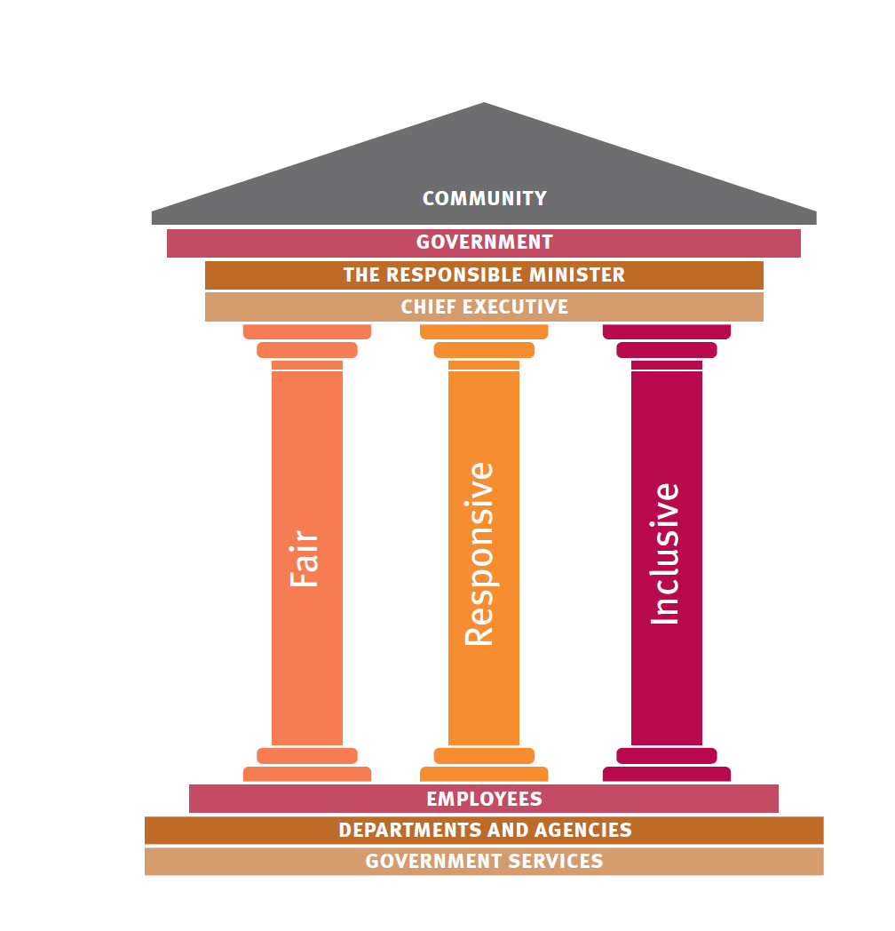

### Fair

Fairness is an inward-looking lens, influenced by the relationships among and between employees and their management. Fairness is found in:

* a meaningful job with opportunity to develop personally and professionally
* fair conditions of employment
* management action that is reasonable and appropriate in the context of respectfully conducted relationships
* an ability to test or challenge adverse decisions in accessible, independent and responsive forums.

Fair management action necessarily includes the employer’s ability to sanction misconduct, inappropriate conduct, underperformance, incapacity and work attendance issues. The key issue is what statutory settings afford a workable balance between management’s prerogative and fair and respectful treatment in employment issues.

### Responsive

Responsiveness has two main aspects: responsiveness to community and responsiveness to government, as depicted in Figure 2.

Figure 2: Responsive to Community and to Government

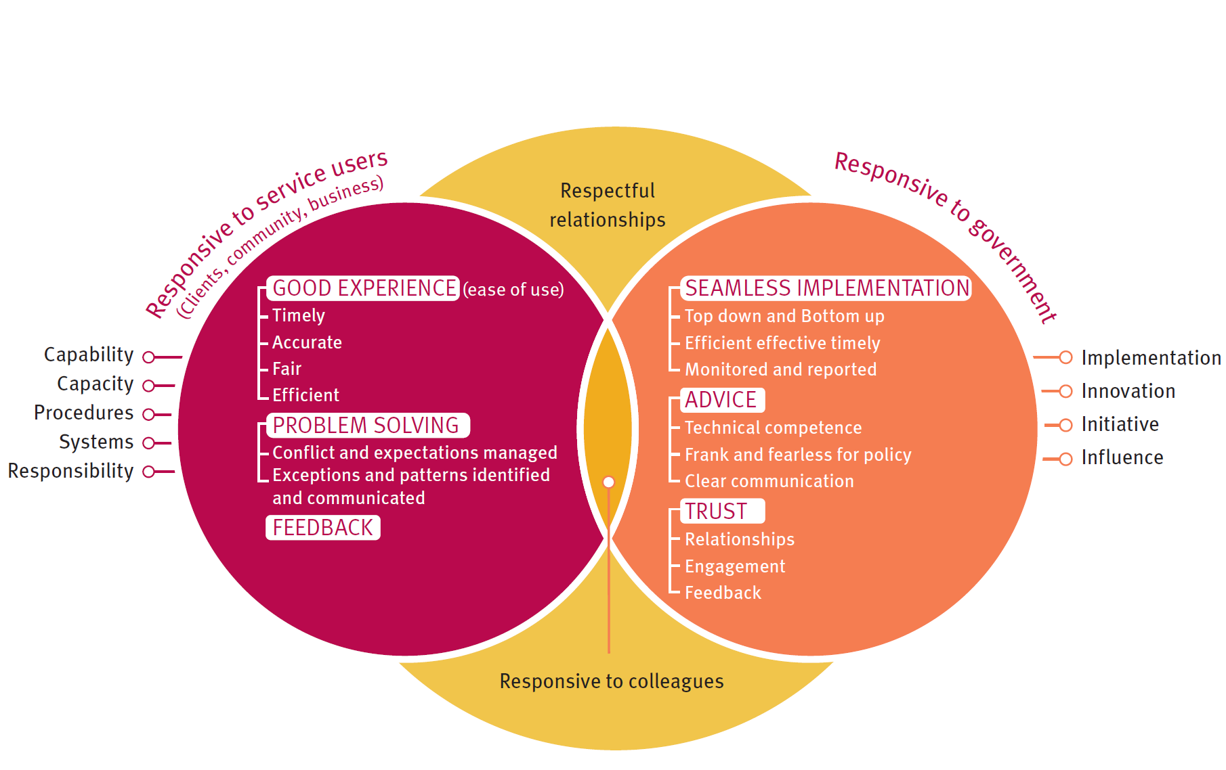

Responsiveness to the community is employees doing their jobs competently, supported by adequate resources and systems, dealing well with complications and exceptions, and working effectively within an overall system, including giving and receiving feedback and acting on it.

Responsiveness to government is the public service adapting to change, implementing policy, providing high quality and timely advice, ensuring efficiency and economy, and initiating change when relevant. Trust is a recurring theme among stakeholders about responsiveness. Feedback is important to gaining and maintaining trust but there is tension between independence and responsiveness.

Additionally, responsiveness to colleagues, providing support and guidance, identifying the need for change or improvement, and working effectively within teams and hierarchies provides a context for respectful employment relationships and a positive approach to high performance and efficiency.

### Inclusive

‘For all’ connotes inclusivity and access: services are responsive to different needs; recruitment is open; the public sector is diverse and reflective of, or able to understand, diverse community needs.

Merit remains a core concept of public employment, not just to protect against improper practices, but to build confidence that the best possible people are working on the government’s behalf. But there is also a real demand for the public service to be diverse and inclusive as well as meritorious.

1. ISSUES

# Why a review?

## Employment

Ask a group of public servants who they work for, who employs them, and there might be many different answers:

* their branch or department, a school or hospital, or a particular statutory body
* they might name a person: the Director-General, their manager, the school principal
* they might say ‘the State Government’, ‘the people of Queensland’, ‘the community’ or even ‘my patients’ or ‘my students’
* some might say ‘the public service’.

In many ways the answers do not matter. Generally, people have a job to do; they go about doing it competently and get along with colleagues and clients alike. But in some other ways it is very important.

|  |
| --- |
| Case study: Jason |
| Jason was employed in the Department of Public Works. His job as security officer was at the Queensland Cultural Centre, run by a different department, Arts Queensland. He tripped over at work in a dimly lit area where construction works were in progress. He was injured and sued for damages and made a Workcover claim. His complicated case involved three government agencies and questions of the State Government liability both as employer and as occupier of the Cultural Centre. The judge initially decided Jason was employed by the Department of Public Works and the centre occupied by Arts Queensland.[7] The Court of Appeal disagreed:  [24] For that to be right the Department of Public Works had to be a juristic person,[8] or have sufficient attributes of a juristic person to allow it to be sued. Ordinarily only natural persons and corporations have that capacity …  [31] The respondent was employed by the State of Queensland, or the Crown in right of Queensland, and not by the Department.[9]  Because the employer and occupier were the same legal entity, the State, Jason could not claim damages against each department separately. |

For public servants in departments, the legal employer is the State, but across the sector the correct answer depends on the circumstances.

For example, Building Queensland is a statutory body that does not represent the State, but it can employ people either under the *Public Service Act 2008* or directly under its own Act.[10]

Someone working in a hospital might be employed under the *Hospital and Health Boards Act 2011* by a particular service such as the North West Health and Hospital Service. But eight of the 16 services can only directly employ senior staff. For those services, called a “non-prescribed service”, the Director-General of Queensland Health appoints employees in the department as a “public service officer” even though employment is not in the public service and not under the *Public Service Act 2008.*[11]

This complicated relationship is shown in Figure 6 on page 42.

The pathway to discovering the employment relationship is convoluted. Table 1 shows how it works under the *Public Service Act 2008* (for a public service officer in a department).

Table 1: Tracing employment under the Public Service Act 2008

|  |  |
| --- | --- |
| Pathway | ***Extract from Legislated Act / Commentary*** |
| Start with the definition of ***appoint***, at the back of the Act in schedule 4 | ***appoint***, a person as a public service officer, means—  (a) for a person who is not already a public service officer—employ the person as an officer; or  (b) for a public service officer—promote, transfer or redeploy the officer. |
| Authority to appoint is with the department’s chief executive | **119 Appointment**   1. A chief executive may, by signed notice, appoint public service officers in the chief executive’s department. |
| Jump back to section 10 to find out who is a chief executive (e.g., Director-General) | **10 Who is a *chief executive***   1. A chief executive, in relation to a department, is the person who holds appointment under this Act as the chief executive of that department. 2. The chief executive, of a person who is a public service employee, is the chief executive of the department in which the person holds appointment as a public service employee |
| Check if the role is in this department | Look to the public service departmental arrangements notices made under sections 14-20 of the *Public Service Act 2008* and s. 24AA of the *Acts Interpretation Act 1954*, and the administrative arrangements orders made from time to time under s. 44 of the *Constitution of Queensland Act 2001*. The departmental arrangements notices are arguably the most impenetrable set of documents in this review. It is a lot easier to see if the Public Service Commission has published a summary of changes.[12] |
| Check who can make the appointment on the Director-General’s behalf | 1. **Delegation** 2. A chief executive may delegate the chief executive’s functions under an Act to any appropriately qualified person. 3. A delegation of a function may permit the subdelegation of the function. |
| Back to the definitions in schedule 4  Read that with section 27A of the *Acts Interpretation Act 1954* and the delegation | ***appropriately qualified***, in relation to a delegated function or power, includes having the qualifications, experience or standing to perform the function or exercise the power.  *Example of standing—*  *a person’s classification level in the public service* |
| The delegate might be the appointee’s manager – see section 26(4) for a guide | ***public service manager*** means a public service employee whose duties involve or include managing other public service employees in the carrying out of their duties. |
| The link back to the State is first in section 219(2) | **219 Effect of Act on the State**  (2) A person who employs another person under this Act employs the person as the authorised agent of the State. |
| … and then in s. 11(1) | **11 Relationship between chief executives and their public service employees**  The chief executive of a department is, for the State, responsible for the employment of public service employees of that department. |

Many people are employed as public servants outside departments in public service offices, or outside the public service in Hospital and Health Services and hundreds of other government entities.

Any government legitimately wants the public sector to be responsive to its priorities. If employees do not understand their link back to the State, they can be disconnected from it.

A change of government direction might seem unimportant if you see yourself as working for a school or hospital and not the government. If your job is to respond to students or patients or the local community, why would the Minister or Director-General matter?

|  |
| --- |
| Symbols of belonging From time to time, the Queensland Government has made symbolic efforts to build stronger civic understanding across Queensland government employees.    The Beattie Government’s corporate logo was intended to be about unity of the public service, separate from but responsible to Ministers, yet still all State Government. The state coat of arms, reserved for Ministers alone, was emblematic of their different role.    The Newman Government’s changes to ‘one minister, one department’ and rejection of the logo was another such effort, symbolic of overarching ministerial responsibility.  No doubt politics was important in both these choices, and earlier ones,[13] but they were sincere attempts to build a sense of identity with the State-as-employer, and the legitimate expectation of responsiveness to the government-of-the-day. |

The complicated legal pathway and artificial language goes back many years – to the 1920s and earlier.

It is not just a Queensland thing. Public employment Acts around Australia and internationally make hard reading. The law governing employment relationships in government is complicated and maybe a rich language is needed to describe it, but some other jurisdictions have clarified relationships and simplified language, as the following Tasmanian example shows. This centralised approach may or may not be useful in the Queensland context with its much larger geography and population and a different history.

|  |
| --- |
| **Case Study: Tasmania – the Employer** |
| The Tasmanian *State Service Act 2000* was amended in 2012 in a major realignment and unification of public sector employment responsibilities.[14]  The revamped Act designates the Premier as **the Employer**. [15]  Obviously the Premier cannot actually be the Employer for every State employee, so the Act provides for a **Head of the State Service**, to ensure the **State Service** is run effectively and efficiently. The Head of the State Service does all the work of the Employer except for issuing Employment Directions, thus ensuring some separation of political decisions from employment decisions. Employment power is in turn delegated to heads of agencies.  The Secretary, Department of Premier and Cabinet, is the Head of the State Service, and the Department of the Premier and Cabinet includes a State Service Management Office that advises and provides support on workforce management and relations, workforce development and workforce reform. |

Queensland’s public employment laws include more than 90 Acts providing for employment in public services, other public entities and particular statutory roles. Close reading of these Acts is sometimes needed to fathom the employment arrangements. The artificial language of the *Public Service Act 2008* and the *Hospital and Health Boards Act 2011* and other Acts tends to obscure employment relationships and raises barriers to working in, and managing, a public service that is fair, responsive and inclusive.

Attachment 4.1 – Public employment pathways, shows the various employing Acts.

1. The review will address the employment relationship and how it can be made more transparent. Comment is invited on this issue.

## Discipline and performance

Stakeholders across the board raised concerns that discipline and performance management under the *Public Service Act 2008* is technical and complicated.

There is no doubt that these issues are stressful for affected employees and difficult for managers.

It is common to categorise concerning conduct about:

* performance (not doing the job, not doing it well enough), or
* misconduct (bad behaviour).

|  |
| --- |
| Case Study: Discipline can go wrong |
| *Wirth v Mackay Hospital and Health Service & Anor* [2016] QSC 39 illustrates how complicated (and expensive) investigations and discipline can be. Justice Bond’s decision describes the background:  [1] By about August 2014, the first respondent, Mackay Hospital and Health Service (“the Hospital”) had a serious problem in its emergency department.  [2] The Hospital had received complaints concerning a communication and working relationship breakdown between staff in the department. The problem was longstanding. Amongst the issues identified as contributing to the problem had been the alleged behaviour of the applicant, Dr Wirth. The acting chief executive of the Hospital formed the view that the problem had reached the stage in which it might compromise patient safety.  The Hospital engaged a major law firm to investigate and report. It interviewed 34 witnesses, including Dr Wirth. Eventually after a draft report and final report, a show cause notice to Dr Wirth, submissions calling for the information about the alleged breaches, disciplinary findings, and submissions on penalty, Dr Wirth was dismissed for misconduct. He appealed to the Queensland Industrial Relations Commission and then sought judicial review in the Supreme Court, where the decisions were quashed (declared invalid). Dr Wirth was “awarded huge backpay”.[16] |

The case involved eight hearing days at the Commission, two Supreme Court hearings, and legal bills on both sides for solicitors and barristers. No doubt the workplace was seriously disrupted, management time diverted, and Dr Wirth and his family distressed.

The case reflects much of the stakeholder feedback from both employers and employees:

* performance and discipline are distinct issues but are lumped together in the Act
* first line managers (a person’s direct manager and the manager’s manager) are not necessarily well skilled at managing difficult relationship issues
* early, positive intervention is far preferable to matters festering and escalating
* there is a perception that managers and human resource support are risk averse, leading to technical approaches, a tendency to delay early intervention, and formal processes rather than positive management, sometimes leading to employee perceptions of ambush
* there is a tendency to see poor performance and discipline as legal disputes, and for both sides to ‘lawyer-up’
* ultimate responsibility lies with chief executives but they are often not personally involved until it is too late to make a difference
* review and appeal checks available to an employee are at the end of the process, often too late for negotiated outcomes, and they are technical and opaque processes in a legal environment, the Queensland Industrial Relations Commission
* employees’ rights can be swamped by legality and technicality [17]
* management skills improvement is fractured and responsibility for it diffuse.

Some State Government departments and agencies have dedicated units charged with assisting the chief executive in managing poor performance and discipline, called “ethical standards units” or similar. In other agencies human resources manages or assists managers in investigations and discipline.

Employee stakeholders expressed contradictory views about the role of such units and human resource branches. Some considered outsourcing investigation to lawyers and workplace investigators (as in the Wirth case study) as a negative. Others thought in-house support was deeply slanted to management and unlikely to yield a fair process. Others still thought ethical standards units allowed managers to abrogate their responsibility.

Everyone consulted for this issues paper wanted performance, discipline and workplace investigation to be done better, to be less technical and costly and less disruptive.

Stakeholders agreed that early management is the key to better procedures, but there is dis- agreement about how to improve first line management skills, and who should have responsibility for it under chief executives.

1. What can be done to improve first line management skills so that performance and conduct issues are addressed early and effectively?
2. What would ensure performance improvement is adequately differentiated from disciplinary proceedings?
3. How can risk assessment be used to facilitate early resolution?
4. What processes would improve the support given to the chief executive in managing discipline and improving performance?

The *Public Service Act 2008* does not cover the entire Queensland public sector. It fully covers all departments and the public service offices (Schedule 1 of the Act), roughly 120,000 FTE. It partially covers another 110,000 FTE through provisions relating to discipline, EEO and the review functions. Public sector employees in Government Owned Corporations and Queensland Rail are only covered by the EEO provisions – roughly 15,000 FTE.

Attachment 4.2 shows which provisions of the *Public Service Act 2008* apply to non-public service agencies, drawn from the *Public Service Regulation 2018*.

Figure 3: Coverage of the Public Service Act 2008 (a rough guide)[18]

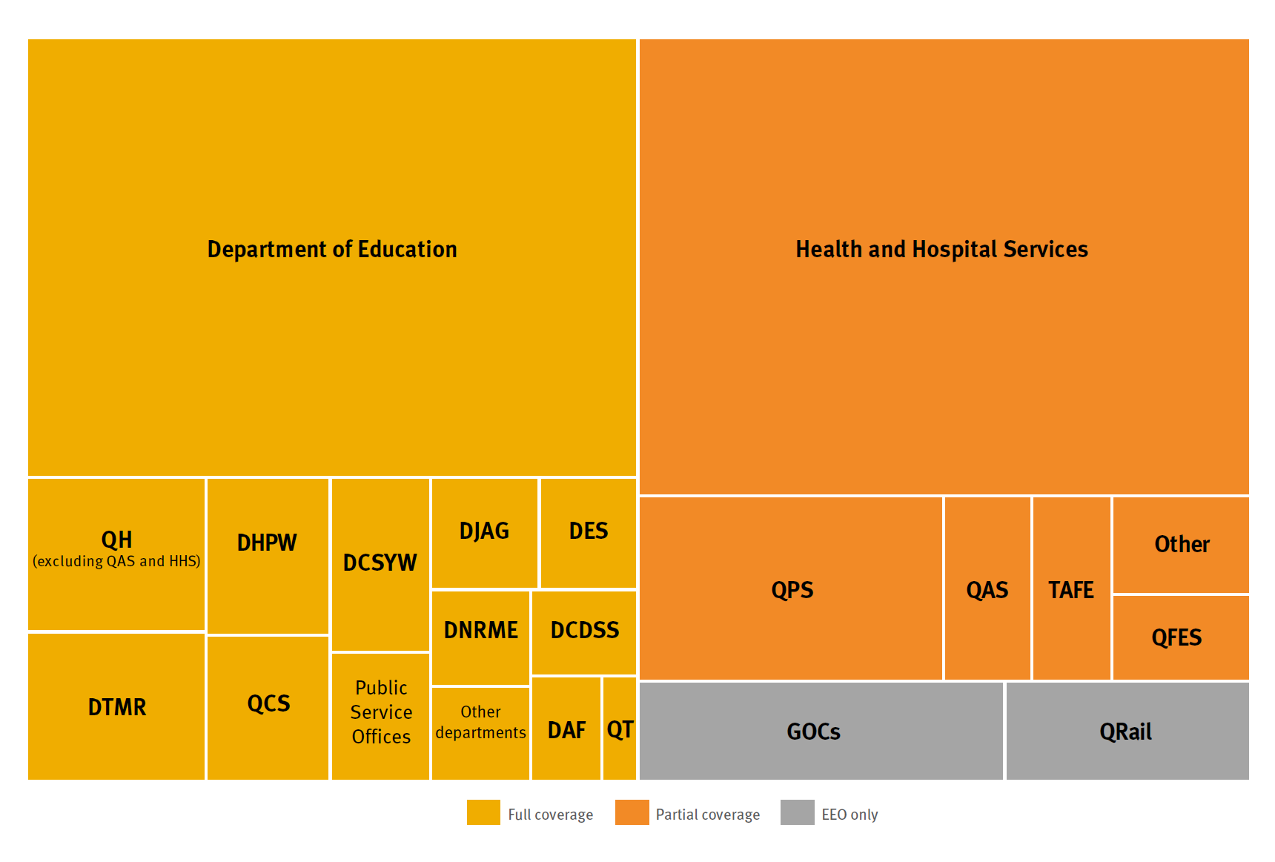

Figure 3 demonstrates the complexity of this application of the *Public Service Act 2008* in part to some employees. [19]

* Almost 90 per cent of Queensland Health staff are in Health and Hospital Services, employed under the *Hospitals and Health Boards Act 2011* while the rest are employed directly by the department as public servants.
* Some 4000 civilians are employed by the Queensland Police Service, either directly or through the Public Safety Business Agency.
* Teachers in the State school system are employed under *Public Service Act 2008*, but TAFE teachers and other staff are not.

Stakeholders were concerned that the experience of employment can diverge widely across employing entities, and in health, between Hospital and Health Service boards. The results include perceived unfairness in practices (such as requiring a transferring employee to resign and therefore lose entitlements); barriers to mobility because agency practices are so different from each other; and complexity in emerging employment patterns where an employee might have jobs in different agencies.

The review returns to this issue below when considering the role of the central human resources agency.

## A new Act?

There is consensus among stakeholders in relation to the *Public Service Act 2008* that:

* the language of the Act is dated and artificial
* concepts do not reflect current challenges
* the Act seems static in a dynamic world
* it is determinedly institutional
* it is negatively rather than positively framed
* it is procedurally dense.

Government employment is also fractured across multiple services and entities, multiple frameworks and multiple Acts rendering the *Public Service Act 2008* less relevant and management inconsistent and possibly unfair between institutions.

As one stakeholder observed “the *Public Service Act* is no longer fit for purpose.”

## More about employment

Employment is a legal relationship between an employer and an employee. It concerns provision of labour by the employee to the benefit of the employer.[20] It is sometimes called a contract “of service” reflecting ancient ideas of master and servant and relative status. Employment at common law is no longer status based (master-servant) but contractual.[21]

Whether a work relationship is one of employment or, for example, an independent contractor or an agent, depends on the substance of the relationship.[22]

Employment necessarily includes knowing what an employee is required to do and where to work.

Employment is characterised by:

a collection of functions, duties and responsibilities entrusted, as part of the scheme of the employer’s organisation, to a particular employee.[23]

### Government employment as a special case

There is a complex legal history of the relationship between “the Crown” (the State in Queensland) and its employees. On one view, Crown employment was not employment at all but appointment to an office, and there were no rights to enforce terms of engagement (e.g., sue for unpaid wages or seek remedy for unfair dismissal):

There is a fundamental difference between the domestic relation of servant and master and that of the holder of a public office and the State which he is said to serve. The constable falls within the latter category. His authority is original not delegated and is exercised at his own discretion by virtue of his office: he is a ministerial officer exercising statutory rights independently of contract. [24]

Public employment has also evolved to be understood as contractual in nature. For many public employees, there is no contractual document, employment being by appointment to perform stated duties in a particular organisation. The ‘contract’ is an amalgam of the appointment, duties, organisational assignment, the Act, industrial instruments, and lawful directions.[25] Just who has power to make the appointment is important, and needs to be made clear.

Government employment is a special case and public employment Acts therefore have important work to do:

* provide clear power for the State to employ people
* distribute authority to employ others on behalf of the State
* describe who is the employer, or responsible on the employer’s behalf
* provide for the necessary incidents of employment including assignment to an organisation, duties and reporting relationships
* describe rights and obligations in employment, including transfer and redeployment, rights of appeal and review
* deal with specific issues like vicarious liability and civic participation
* give organisational form to government.

### Public Service Act employment

The Queensland public service proper[26] is described in the Act first by **institutions**:[27]

1. departments staffed by public service employees,[28] appointed under the *Public Service Act 2008*. Each department is headed by a “chief executive”, mostly a Director-General,[29] who is responsible on the employer’s part, and
2. public service offices staffed by public servants (also appointed under the *Public Service Act 2008*) headed by various officers usually appointed under particular Acts;

and then by **status**, top down (reflecting the institutional focus of the Act):[30]

A person is a public service officer if the person is employed under this Act as—

(a) a chief executive, or

(b) a senior executive, or

(c) an officer of another type.

The complexity of the language used in the Act is shown in Attachment 4.3 – Type of appointment – that details the language of the *Public Service Act 2008* for employees and the institutions where they work.

The current departments and other public service entities are listed in Attachments 4.4 – Queensland public sector agencies – and 4.5 – Public service offices – and for comparison, those of other jurisdictions are in Attachment 4.6 – Departments and agencies in other States and Territories.

## The value of public services

Much civic life depends on orderly rule-based systems that are predictable, allowing individuals, community organisations and businesses to plan and go about their activities.

Public services are crucial in the creation and maintenance of those rules and systems and ensuring their predictability.

|  |
| --- |
| **Case study – State and non-State schooling** |
| It is long-standing policy in Queensland that children must be given an education. Schooling is compulsory but parents may choose between State schools and non-State schools.  Education is a responsibility of the Minister for Education. State schools are administered under the *Education (General Provisions) Act 2006*. State school teachers are public servants in the Department of Education.  Non-State schools must be accredited under the *Education (Accreditation of Non-State Schools) Act 2017* to ensure (among other things) schools are providing quality education services and are properly governed. Staff of non-State schools are not public servants.  Teachers in all schools must be registered under the *Education (Queensland College of Teachers) Act 2005*, and what is taught is governed under the *Education (Queensland Curriculum and Assessment Authority) Act 2014*.  The public interest in educating children is managed by orderly rules-based systems of management of State schools and accreditation of non-State schools, for example, teacher registration and determination of syllabus, that give confidence in the system to all participants and ultimately ensure a high educational standard in Queensland. Public servants are responsible for administration of the rules and systems of each element in this large policy framework. |

### An employer of choice

The idea of the public service as employment of choice is stated in the *Public Service Act 2008* section 25(1)(f):

Public service management is to be directed towards … promoting the Government as an employer of choice.

There is a rich literature about what motivates public service employment.[31] Perry’s work focused on intrinsic motivation (the appeal of policy-making, commitment to public interest, compassion, altruism). Extrinsic factors are also important, including organisational culture, political dimensions, and remuneration.[32] Negative factors also impact on perceived value.[33]

Why would people choose government employment? Here are some the influential factors:

|  |
| --- |
| Practical employment options For some occupations public employment dominates (e.g., teaching, nursing, public administration, public policy). The public sector is a large employer of many other professions, and an attractive option for many generalists and school leavers. Content Many employees choose government because of the topics they get to work on and are interested in or passionate about. Some employees enjoy being able to make a difference. Service Much work in public employment is inherently gratifying, whether meeting community needs or assisting the government to make the best possible policy choices. Work-life balance The public sector nationally has led in providing workplace flexibility, such as parental leave and part-time options. For some this is a great attraction. Employment security Allied is the security of public employment, with many employees holding ‘tenure’, a central feature of traditional public service employment. (See below about the use of contracts and temporary and casual work.) Prestige Some public employment is highly sought after for its status, especially the most senior roles. Other conditions Public sector superannuation used to be significantly higher than the private sector, compensating for lower wages. This paid off at the end of a long career.[34] (Pay and superannuation have evened out, especially with the end of defined benefit schemes.) Affiliation Affiliation with an organisation can be attractive. Some agencies have many long-term employees who express dedication to their department or sector (e.g., agriculture and public works both have many long serving staff; some teachers are dedicated to the ideal of public education). |

Public sector employment is often a practical choice, especially for the growth areas of education and health where public services dominate the employment market.

For some professional groups, the relatively controlled working environment of the public sector is preferable to highly competitive work elsewhere. Work and life may be easier to balance in the public sector, and conditions are more reliably flexible, but the private sector is catching up.

1. The Act requires management to work towards the public service being an employer of choice. Input is invited on how the Act can facilitate this.

In broad terms there are three types of roles in public service illustrated in Figure 4:

Figure 4 Three role types of public employees

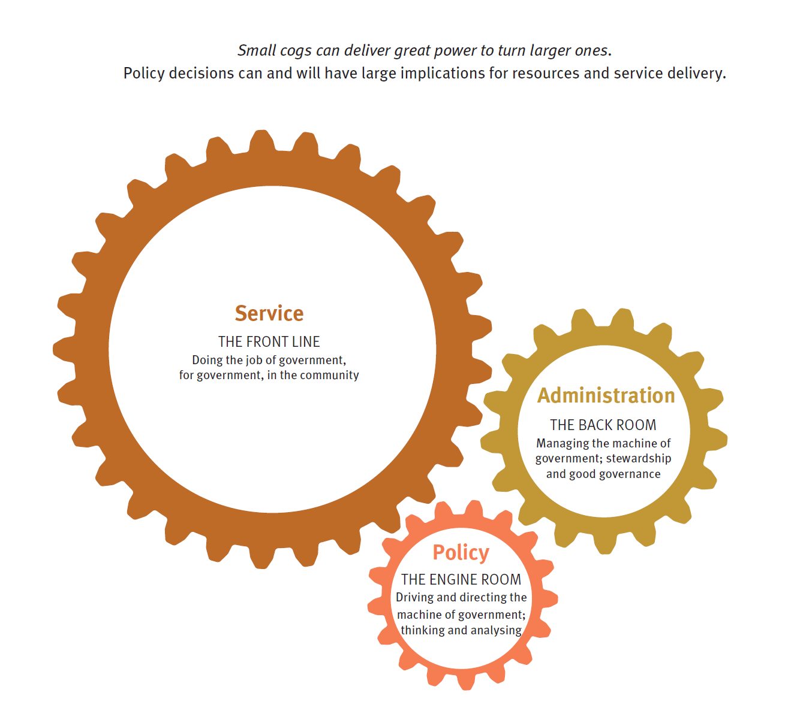

Modern civil service ideals are commonly understood in the context of the Northcote-Trevelyan Report (1854), and informs the tradition of a public workforce that:[35]

* endures beyond political and electoral cycles
* is apolitical
* is selected, appointed and promoted on rational and objective grounds (‘merit’)
* is expertise-based and professional service
* operates under the rule of law
* serves the Government of the day
* retains flexibility to serve future Governments.

### A permanent public service

Permanency is not “a job for life”, but more about a career service, one that endures beyond electoral and political cycles, (so job security is important).

In a contemporary environment “permanent” reflects the need for an endurance of capacity across electoral cycles, changes of government and changes in departmental arrangements.

Section 121 of the *Public Service Act 2008* deals with job security for public service officers other than the executives.[36] The default is “tenure”, a term not defined in the Act. The *Macquarie Dictionary* relevantly says tenure means:

1. a period of office or employment that terminates, possibly subject to certain conditions, only on resignation or retirement.
2. the holding of such an office or employment.

Employment under the *Public Service Act 2008* that is not on tenure is:

* on contract (chief executive, senior executive, section 122)
* temporary (whether time limited or not)[37] or
* casual.[38]

There is also a category of worker unique to Queensland, the general employee.[39]

Chief executive and senior executive contracts are terminable on one month’s notice.[40]

As at June 2018, the Queensland public service accounted for 225,416.5 FTE.[41] Of these, more than 179,000 FTE (almost 80 per cent of the total) were permanent staff. Another 38,000 FTE were temporary staff (roughly 17 per cent), 6600 FTE were casual employees (almost three per cent) and almost 1600 FTE (less than one per cent) were contracted staff.

Across the sector, as the figure below demonstrates, there are wide variations in the balance of employee types between departments and services, reflecting differing needs and patterns of work. For example, almost 96 per cent of Queensland Police Service employees are permanent staff whereas Education, Health and TAFE Queensland have higher proportions of temporary employees, reflecting those agencies’ need for flexibility in management and deployment of resources to meet changing patterns of need or demand.

Figure 5: Appointment type by department, June 2018 (Queensland public service workforce statistics)

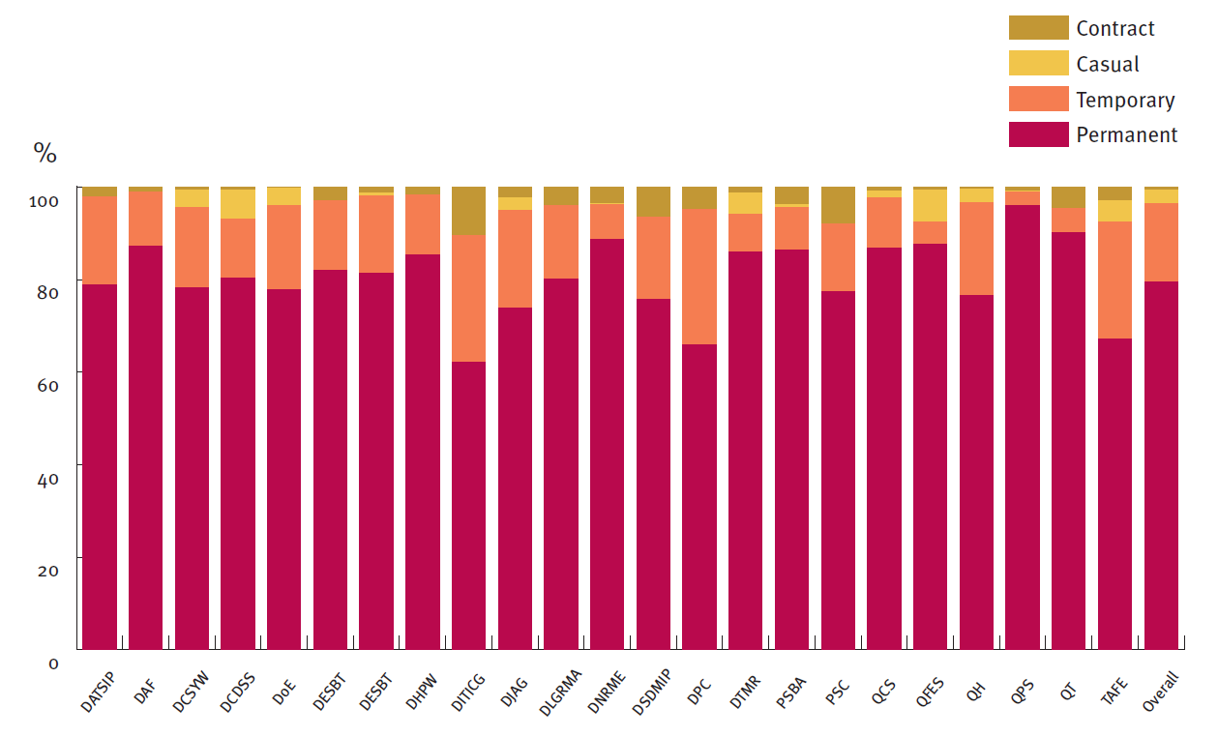

Note: data for the Department of Innovation, Tourism Industry Development and the Commonwealth Games is skewed as the department employs fewer than 200 FTE, of whom 27 FTE are currently temporary staff.

There are some 16,659 FTE employed under the *General Employees (Queensland Government Departments) and Other Employees Award*. Some 15,410 FTE are employed in the Department of Education – almost 93 per cent of the total.

Of the remaining 1249 FTE, 454 FTE are employed in the Department of Child Safety, Youth and Women and 301 FTE are employed in the Department of Transport and Main Roads. A further 219 FTE are employed in the Department of Agriculture and Fisheries and 117 FTE in the Queensland Art Gallery. The remainder are spread between seven departments and the State Library of Queensland. QPS staff members are employed by the Commissioner under chapter 5 part 5 of the *Public Service Act 2008*, under heading General and temporary employees

**Conversion of Temporary and Casual employees**

In the period June to September 2018, Queensland government departments and Hospital and Health Services completed 1,042 reviews of temporary employees’ status. Following review, 350 temporary employees were converted to permanent representing just over one third of all cases.

About two-thirds of the reviews were in Queensland Health and the Hospital and Health Boards (656). Of these reviews, 131 employees were converted to permanent, approximately 20 per cent.

In the same period, 92 casual employees applied to have their status converted to permanent, 78 in health.

Fifty-four were accepted and the employees concerned had their employment status converted to permanent. One other employee was offered a permanent position but declined to convert. The rate of conversion offered was therefore about 60 per cent.

The idea of permanent public services has changed with widespread adoption of fixed-term, renewable contracts for senior executives, use of temporary and casual engagements, outsourcing, contracting out, commercialisation and privatisation.

Temporary employees’ status must be reviewed by the departmental chief executive after two years and then annually to decide if the employment should be changed to on-going employment, whether as a permanent general employee or a tenured public service officer.[42]

Casual employees have a similar review right, shortly to be echoed in private employment.[43]

Stakeholders have expressed concerns about how well these conversion provisions operate and if they are fair.

1. Can the temporary and casual conversion provisions, and the review of related decisions, be improved?

### Separation: ending of employment

Voluntary separation. There is some suggestion in old law that Crown officers had no right to retire or resign and might do so only with permission. A public employment act is needed to regulate separation from employment. The *Public Service Act 2008* affords employees the right to voluntarily cease employment by resignation[44] or retirement after age 55,[45] with a short period of notice. There is also a scheme for voluntary redundancy or voluntary early retirement.[46]

Involuntary separation. The circumstances in which the State-as-employer may dispense with the services of an employee against the person’s will are important for job security, and logically should be circumscribed to ensure termination is for a proper reason. Job security is important in the private realm too, and dealt with by the *Fair Work Act 2009* (Cth).

The *Public Service Act 2008* contemplates termination of employment involuntarily:

1. during probation[47]
2. “for cause”, in a disciplinary process[48]
3. for incapacity (“ill health retirement”)[49]
4. the job or position is no longer required[50]
5. unilateral termination as a contractual right, or non-renewal of a completed contract[51] and
6. the prerogative to dispense with services.[52]

There are industrial protections for unfair dismissal in some cases.[53].

Redundancy. The *Public Service Act 2008* sections 42 and 138 deal with the question of who may decide employees are surplus to requirement and how that decision is made.

**42 Minister may direct action about surplus public service employees**

(1) This section applies if the Minister is satisfied more public service employees are employed in a department than it needs for the effective, efficient and appropriate performance of its functions.

(2) The Minister may direct the department’s chief executive to take action in accordance with relevant rulings of the commission chief executive.[54]

**138 Action because of surplus**

(1) This section applies if the chief executive of a department believes a public service employee is surplus to the department’s needs because—

(a) more employees are employed in the department than it needs for the effective, efficient and appropriate performance of its functions; or

(b) the duties performed by the employee are no longer required.

(2) The chief executive must take the action required under a directive.

Redundancy is also dealt with in industrial laws and instruments.

1. Is the category of general employee useful? What are the implications if general employees are treated the same as other public service employees?
2. What criteria should apply to a decision that an individual employee is redundant, or that there are more employees than necessary in a department or other entity?
3. Are there any comments on the terms of employment for other types of employee (for example, contract including executive contracts), or about redundancy?

## Merit and diversity

A public service chosen on merit rather than preferment or partisanship was a bedrock reform of the 19th century. Merit remains core to public employment in Queensland. Sections 27 and 28 of the *Public Service Act 2008* state the paramountcy of merit:

**27 The merit principle**

The selection, under this Act, of an eligible person for an appointment or secondment as a public service employee must be based on merit alone (the **merit principle**).

**28 Merit criteria**

In applying the merit principle to a person, the following must be taken into account—

(a) the extent to which the person has abilities, aptitude, skills, qualifications, knowledge, experience and personal qualities relevant to the carrying out of the duties in question;

(b) if relevant—

(i) the way in which the person carried out any previous employment or occupational duties; and

(ii) the extent to which the person has potential for development.

In the real world, merit eludes precision, squeezed between managerialism, the demand for efficiency, the need for equal opportunity in employment and representativeness, and renewal.

It is beset by definitional problems, sometimes reduced to procedures, and sometimes framed defensively: checking the merit box is appeal-proofing the selection process.

It is common to hear of the “merit myth”:

A merit-based, permanent career civil service, in which those at the very top were an elite of anonymous, objective, disinterested, party politically neutral officials, who were able by virtue of those characteristics, to give ministers sound, direct and honest advice and always to act in the public interest, is a powerful myth.[55]

An even more challenging perspective arises from feminist readings of how merit works in practice in the business world: merit disguises cognitive biases and is inherently subjective; it assumes an even playing field that simply does not exist; who you know still matters more than what you know; and merit justifies the cloning effect in big organisations.[56]

Further there are challenges to merit arising from international adoption of complementary (if not competing) principles such as:

* Diversity: the breadth of talent attracted to work: openness to employing, retaining and developing people from different backgrounds, viewpoints, cultures, gender and races etc
* Inclusion: active engagement at work, and including others in tasks, teams, and conversations
* Balance: valuing unique viewpoints and contributions beyond categories, and aligning the espoused values of diversity and inclusion to actions
* Belonging: fostering connection individually and collectively.

Some stakeholders believe mandatory training should be required before people can participate in selection processes, including training in unconscious biases.[57]

Attachment 4.8 – Merit in public employment shows how merit is stated in some other laws.

Formal merit protection is by way of promotional appeal to the QIRC, though anecdotally there are very few such appeals.[58]

1. Are changes needed to make the merit principle work better in practice?
2. How can the merit principle better align with other objectives such as diversity, inclusivity and belonging?
3. What is the role of the central personnel agency in protecting the merit principle?
4. What process should be used for formal merit protection action?

## Equal opportunity; Gender pay equity

The *Public Service Act 2008* in chapter 2 (sections 30–35) incorporates aspects of the former *Equal Opportunity in Public Employment Act 1992*, including the “EEO obligation”, and reporting and compliance matters.[59] The 2008 version is less detailed and procedural than the original.

The Act addresses EEO target groups:

* Aboriginal and Torres Strait Islander peoples
* migrants and their children whose first language is not English
* people with disabilities and
* women.

A regulation can add other groups, but none has been added.

As well as the four groups of people listed above, the State Government’s strategies also include young people, older people and LGBTIQ+ people.[60]

The Public Service Commission has developed several strategies relevant to equal employment opportunity, including:[61]

* inclusion and diversity
* gender equity strategy and
* inclusion Champions of Change.

Union stakeholders expressed a preference for the Act to include some of the now-discarded provisions to improve outcomes, performance and engagement, especially the obligation to consult with employees and unions.

Stakeholders across the board expressed general concern that the model is not delivering the intended changes in workforce profile and organisational culture and needs to be refreshed.

**Gender pay equity** is dealt with in the *Industrial Relations Act 2016*.[62] The *Public Service Act 2008* does not specifically address gender pay issues, and it seems alignment of industrial and employment frameworks should be considered.

Specific issues raised by stakeholders for gender inclusion and pay equity included:

* access to professional development
* gender imbalances in leadership roles
* measurement of work for increments and promotion where employees work part-time
* structural issues with part-time and job-sharing in the senior executive
* bureaucracy around reporting requirements.

Pay equity is an issue in other places:

* New Zealand has recently announced gender pay equity initiatives that go beyond aligning industrial and employment processes and reporting, including collaborative processes, work flexibility by default, addressing discrimination and bias in human resource practices, improved measurement and reporting and gender balanced leadership[63]
* the United Kingdom has increased its reporting requirements as part of a new diversity and inclusion strategy[64]
* Canada includes gender pay equity in its *Human Rights Act 1985*, section 11.

1. What improvements can be made to enhance the equal employment opportunity processes and obligations?
2. How should the Public Service Act address gender pay equity issues?

### Suspension

The *Public Service Act 2008* has two different powers to suspend employees, one with pay[65] and the other that may be with pay or without pay.[66]

Stakeholders consider the two provisions difficult to understand and administer.

One union was particularly concerned about potential unfairness in the calculation of remuneration for suspension on pay for shift workers.

1. Can the suspension provisions be improved to be made fairer and more efficient to administer?

### Investigations and disciplinary meetings

The *Public Service Act 2008* is silent about how a chief executive or delegate might investigate concerns about an employee. As the Wirth case study on page 17 above shows, investigation can be expensive and if not conducted properly, futile and disruptive. A major concern of employee stakeholders is outsourcing investigations, especially to law firms and workplace investigation companies. Sometimes this is a first resort, usually because departments lack investigatory capacity or are concerned about relationships interfering with objectivity.

Investigation reports whether prepared in-house or outsourced, are sometimes not suitable either to remediate conduct or relationships, or for subsequent formal discipline because they are not well prepared or the underlying process is unfair.[67]

Employee stakeholders were concerned that external investigators often attended meetings with an affected employee effectively representing the employer while unions were prohibited from representing a member – leading to imbalances and unfairness.

1. What factors should guide a decision to outsource investigations?
2. Should there be prescribed limits on the role of external investigators? Is the ‘support’ role in investigations and disciplinary processes useful to ensure fairness?
3. Are there circumstances when an employee should be entitled to representation in investigation and disciplinary meetings?

### Incapacity

The State may transfer, redeploy or compulsorily retire an employee who has a mental or physical illness or disability that causes absence or unsatisfactory performance.

The *Public Service Act 2008* deals with this in chapter 5 part 7, sections 174-179AA: “Mental or physical incapacity”. The provisions apply to other public sector entities, including health and hospital services, the ambulance service, and legal aid.[68] The part includes a statutory power to require an employee to undergo an independent medical examination (**IME**).

The relevant sections are as follows.

**174 Application of pt 7**

This part applies to a public service employee if—

(a) the employee is absent from duty or the employee’s chief executive is reasonably satisfied the employee is not performing his or her duties satisfactorily; and

(b) the chief executive reasonably suspects that the employee’s absence or unsatisfactory performance is caused by mental or physical illness or disability.

**175 Chief executive may require medical examination**

The chief executive may—

(a) appoint a doctor to examine the employee and give the chief executive a written report on the examination; and

(b) require the employee to submit to the medical examination.

**178 Action following report**

(1) If, after considering the report of the medical examination, the chief executive is reasonably satisfied the employee’s absence or unsatisfactory performance is caused by mental or physical illness or disability, the chief executive may—

(a) transfer or redeploy the employee; or

(b) if it is not reasonably practicable to transfer or redeploy the employee—retire the employee from the public service.

Retirement under section 178(1)(b) is sometimes called ill-health retirement.

A decision under the part (to require an examination; to take action by way of transfer, redeployment or retirement) is not appealable.[69] Ill-health retirement constitutes a dismissal for industrial purposes.[70]

Employee stakeholders say the power to require an IME has been used punitively and improperly. They are also concerned the power might be used to require invasive examinations (e.g., tissue and blood samples; body cavity examination; diagnostic imaging), and that psychiatric examination stigmatises employees.

Refusal to attend an IME may be grounds for disciplinary action, including termination of employment.[71] Attempts to prevent an IME by injunction have failed.[72]

Employer representatives consider the provisions complex and difficult to use.

The power has a long history in Queensland[73]and was once considered quite harsh compared with private employment.

Whatever the historical view, the general law seems to have caught up: an employer may require an employee to undergo an independent medical examination in certain circumstances, the leading case in Queensland being *State of Queensland v Attrill*.[74]

The Full Court of the Federal Court in *Grant v BHP Coal* has considered if an implied contractual term empowers such a direction, but did not need to decide in that case.[75]

In *Blackadder v Ramsey Butchering Services Pty Ltd*, Madgwick J in the Federal Court was of the view there is an implied term of an employment contract that an employee may be obliged in certain circumstances to attend an IME.[76] The High Court did not address that question on appeal.[77]

So it seems that the general law, whether by implied contractual term, or as an aspect of the employment relationship, or under the general obligation to ensure a health and safe workplace, allows the employer in some circumstances to require an IME.

The general law is relied on by some State employing entities that do not have recourse to the *Public Service Act 2008.*

There is legal authority that statutory provisions do not necessarily displace the general law power to require an IME,[78] so the general law and the Act may both apply.

1. What circumstances warrant an independent medical examination?
2. What should the rights of an employee be if required to undergo an independent medical examination?

## Organising government

Government legitimately wants to organise its resources to reflect priorities, preferences and ministerial arrangements, to drive change and to maximise efficiency. The arrangement of resources into various agencies under Ministers is done by:

* the Administrative Arrangements Order made under section 44 of the *Constitution of Queensland 2001*, and
* the departmental arrangements notices under the *Public Service Act 2008* sections 14–20, declaring and changing departments.

Together these constitute the “machinery of government” (MoG), one of the key tasks of the *Public Service Act 2008*.

Machinery of government changes are a source of considerable concern to stakeholders.

There real costs are opportunity costs especially in disrupted relationships and work patterns. Yet responsiveness to government necessarily includes a seamless and productive change from one organisational form to another. The same can be said of major changes in policy or the law. Change management capability is therefore needed.

1. How can machinery of government changes be made to work better?
2. How should change arising from machinery of government and policy change be managed?

### Review of organisations

The *Public Service Act 2008* allows for reviews and reports about departments and public service offices, focusing particularly on efficiency and effectiveness and adherence to the management and employment principles.[79] There is considerable procedural formality attaching to the reviews without necessarily enhancing the intent of the review.

A review and reporting power or obligation has long been part of Queensland public employment laws, sometimes controversially. In contrast to the great detail in the 2008 Act (much of it resulting from folding in the former Service Delivery and Performance Commission), the 1922 Act empowered the Commissioner to undertake inspections, and the Act provided for the office and powers of public service inspector.

The current review power sits alongside the Auditor-General’s performance audit mandate,[80] health service investigations and inspections,[81] and education inspections.[82]

Stakeholders report a low appetite for interventionist reviews, often referring to negative experiences over the past 10 years or so. Further, there is tension between the devolved accountability, involving semi-autonomous management, and a central inquisitorial function that might impose standards and structures.

The Public Service Commission currently sponsors “capability blueprints” undertaken cooperatively with agencies to discharge its capability functions.[83]

1. Should a central agency retain power to undertake formal reviews and make reports about agencies? In what circumstances?
2. Are there other ways to systematically ensure continuous improvement and critical examination of agency operations?

### Separate services

Queensland currently has the following major employing services:

* the public service in departments and public service offices (including the chief executive service and senior executive service)[84]
* Hospital and Health Services (eight prescribed services, with Queensland Health the employer for a further eight services), and a health executive service[85]
* Queensland Ambulance Service (staff employed through the Director-General, Queensland Health);
* Queensland Fire and Emergency Services
* Queensland Corrective Services (not a formal separate service but distinct within the Queensland Public Service)
* TAFE Queensland
* police, ministerial and parliamentary services (excluded from this review).

The largest of all Queensland government functions, health, is split between public servants in the department (Queensland Health) and employees under the *Hospital and Health Boards Act 2011*, working in 16 Hospital and Health Services. Each service can employ health service executives (a separate service under the Act) and contracted senior health service employees. Eight of the Hospital and Health Services have a prescribed power to employ staff. The other eight services’ employees are employed for each service in Queensland Health, declared to be a public service office headed by the Director-General for that purpose.[86] The Director-General has overarching responsibilities as system manager for the public sector health system.[87]

This complicated structure is depicted in figure 6.

Employee stakeholders were especially critical of a perceived lack of consistency in employment decisions between different Hospital and Health Services, leading to unfairness, inequality of work value and, in some cases, loss of entitlements.

Figure 6: The Queensland public health system

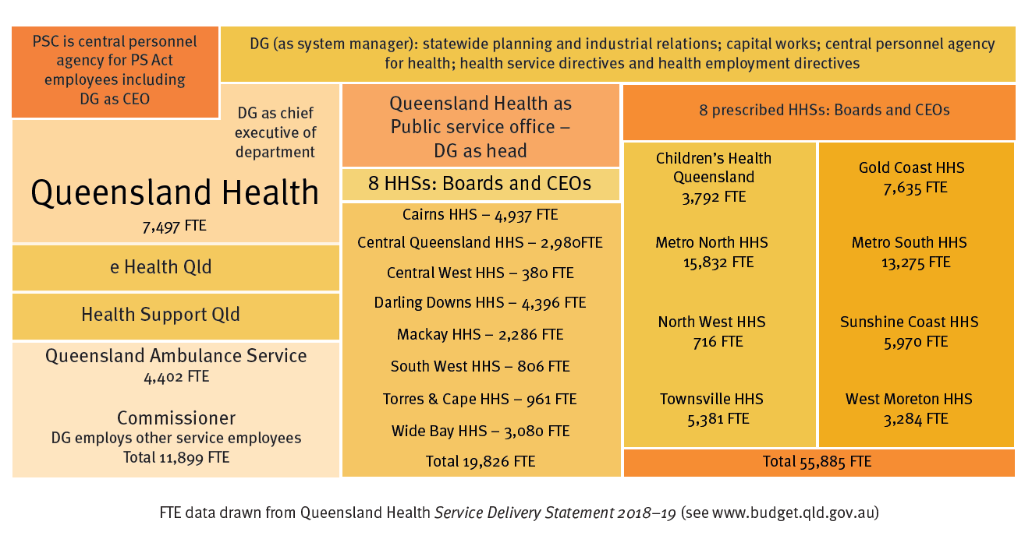

The Queensland Ambulance Service operates as a statewide service within Queensland Health.[88]

The other major separate services are:

* **Queensland Fire and Emergency Services**[89]
* **TAFE Queensland**[90]
* **Queensland Police Service**[91]
* **Queensland Corrective Services.**[92]

|  |
| --- |
| **New South Wales**, in addition to its public service[93] has four separate services:   * teaching service, people employed under the *Teaching Service Act 1980* (NSW); * transport service: *Transport Administration Act 1988* (NSW); * NSW police force: *Police Act 1990* (NSW); * NSW health service: *Health Services Act 1997* (NSW).   **Victoria** uses different language, identifying the public sector bodies that are employers, including departments and administrative offices (that together employ the public service) and public entities. (outside the public service but in the public sector).[94] Victoria Police has the character of a separate service and there was historically a teaching service. |

1. How should consistency within and between services, departments and agencies be achieved?
2. How might services be organised to ensure coherent and integrated management?

## Rights and responsibilities

Public employees have specific rights protected by the *Public Service Act 2008*. They include the right to:

* fair treatment
* make a grievance about management action
* make a complaint
* participate in civic life
* public interest disclosure protection
* appeal and review of certain decisions to the QIRC.

Responsibilities in addition to those required of any employee such as attendance, diligence and honesty include:

* declaration of interests for some employees
* compliance with Codes of Conduct
* disclosure of certain criminal charges or convictions
* work performance and personal conduct principles as specified in section 26.

1. How should the Act provide for and articulate rights and responsibilities?

## Before employment

There are prerequisites to certain types of employment in the public services.

### Citizenship

Section 127 of the *Public Service Act 2008* reserves appointment as a public service officer to citizens and others with rights to work and remain in Australia indefinitely. People outside those categories may only work as temporary or general employees (and not, therefore, as executives or on section 122 contracts).

There are no citizenship requirements in other employing Acts in Queensland, including the *Hospital and Health Boards Act 2011* and legislation covering the separate services (police, ambulance, fire and emergency services and TAFE Queensland).

|  |
| --- |
| The *Human Rights Bill 2018* currently before the Queensland Parliament, adopts the effect of article 25 of the International Covenant on Civil and Political Rights, about ‘access’ to the public service. This is sometimes read as including the right to be employed. Article 25 itself is addressed to citizens; clause 23 in the Bill refers to “eligible persons”, an undefined term, but it is likely eligibility would turn on the *Public Service Act 2008* eligibility. |

Citizenship requirements also apply, or may apply, in the Commonwealth, New South Wales and the Australian Capital Territory.[95]

1. Should the current citizenship requirement be retained?

### Suitability screening

Chapter 5 Part 6 of the *Public Service Act 2008* provides for pre-employment screening, namely criminal history and working with children (blue card) checks. These processes in sections 150-174 consume 22 pages of the Act.

The *Ministerial and Other Office Holder Staff and Other Legislation Amendment Bill 2018* currently before Parliament allows for pre-employment screening of staff in Ministerial offices and the Queensland Parliamentary Service.

Some stakeholders have indicated that these checks are administratively complicated and time consuming, diverting resources from productive work.

1. Could the processes under the *Public Service Act 2008* for blue card and criminal history checks be improved?

### Advertising and Government Gazette notice

Employer stakeholders question the utility, timeliness and cost of gazettal requirements.[96]

Traditionally gazettal was a means of ensuring public notice and transparency of a government’s decisions, and an enduring record. There are now other means of giving notice, including website publication (although that may not be permanent) and the Act contemplates alternatives in some cases.

1. Are there alternatives to gazette publication that ensure transparency and a proper record?

## Management and administration

The *Public Service Act 2008* has a top down approach to administration and management. It starts with major institutional forms, and allocates responsibility to the Premier, departmental ministers, the central agency (Public Service Commission), then chief executives, senior executives, and public service managers.

### Emphasis on the employee

This review starts with a focus on the employment relationship, and therefore with emphasis on the employee, who has a primary obligation of competently doing allocated work, maintaining productive relationships, and attending to personal and career development.

### Access to employment related policies and information

Employee representatives have noted difficulties in accessing information about employment matters, saying employees find it hard to know where and how to find basic documents.

Both managers and employees have an interest in information and policies being easy to find and understand, to ensure fairness and enhance responsiveness.

1. How can the Public Service Act facilitate employee access to relevant policies?

### Promotion

Some stakeholders have expressed frustration with rules around in-house promotion, suggesting that there is a systemic bias towards a full, open recruitment process. A full, merit-driven process ensures equity but also consumes time and energy when sometimes there is an apparently obvious candidate.

Other stakeholders have noted that many promotional opportunities are handled through expressions of interest. Such processes improve management flexibility, but can be a closed shop. Employee representatives noted these closed merit processes can foster employee disquiet, a sense of unfairness and a cloning effect.

1. How can the Public Service Act facilitate a streamlined process that supports, nurtures and promotes existing talent while maintaining fair and open merit-based recruitment?

The *Public Service Act* 2008 approaches work performance and personal conduct in section 26 (1).

**26 Work performance and personal conduct principles**

(1) In recognition that public service employment involves a

public trust, a public service employee’s work performance and personal conduct must be directed towards—

(a) achieving excellence in service delivery; and

(b) ensuring the effective, efficient and appropriate use of

public resources; and

(c) giving effect to Government policies and priorities; and

(d) collaborating with other departments with a focus on

public service-wide priorities as well as department-specific priorities; and

providing sound and impartial advice to the Government; and

(e) providing sound and impartial advice to the Government; and

(f) improving all aspects of the employee’s work

performance; and

(g) carrying out duties impartially and with integrity; and

(h) acting honestly, fairly and in the public interest; and

(i) interacting with staff members under *the Ministerial and*

*Other Office Holder Staff Act 2010* respectfully, collaboratively and with integrity; and

(j) observing all laws relevant to the employment; and

(k) ensuring the employee’s personal conduct does not

reflect adversely on the reputation of the public service; and

(l) observing the ethics principles under the Public Sector Ethics Act 1994, section 4; and

(m)complying with an approved code of conduct and any approved standard of practice as required under the Public Sector Ethics Act 1994, section 12H or 18.

### Public service managers’ responsibilities

An employee’s manager is charged by section 26 (2)-(4) as follows:

**26 Work performance and personal conduct principles**

(2) Also, a public service manager must take all reasonable steps to ensure each public service employee under the manager’s management is aware of the following—

(a) the work performance and personal conduct expected of the employee;

(b) the values of the public service and of the department or public service office in which the employee is employed;

(c) what constitutes corrupt conduct under the *Crime and Corruption Act 2001.*

(3) Further, a public service manager must—

(a) pro-actively manage the work performance and personal conduct of public service employees under the manager’s management; and

(b) if a case of unacceptable work performance or personal

conduct arises, take prompt and appropriate action to address the matter.

(4) In this section—

public service manager means a public service employee

whose duties involve or include managing other public service

employees in the carrying out of their duties.

Of course, in complicated hierarchical organisations, managers are employees who themselves have managers until the chief executive (also a manager) is reached.

This management relationship under the Act is depicted in Figure 7.

Figure 7: Management under the Public Service Act 2008

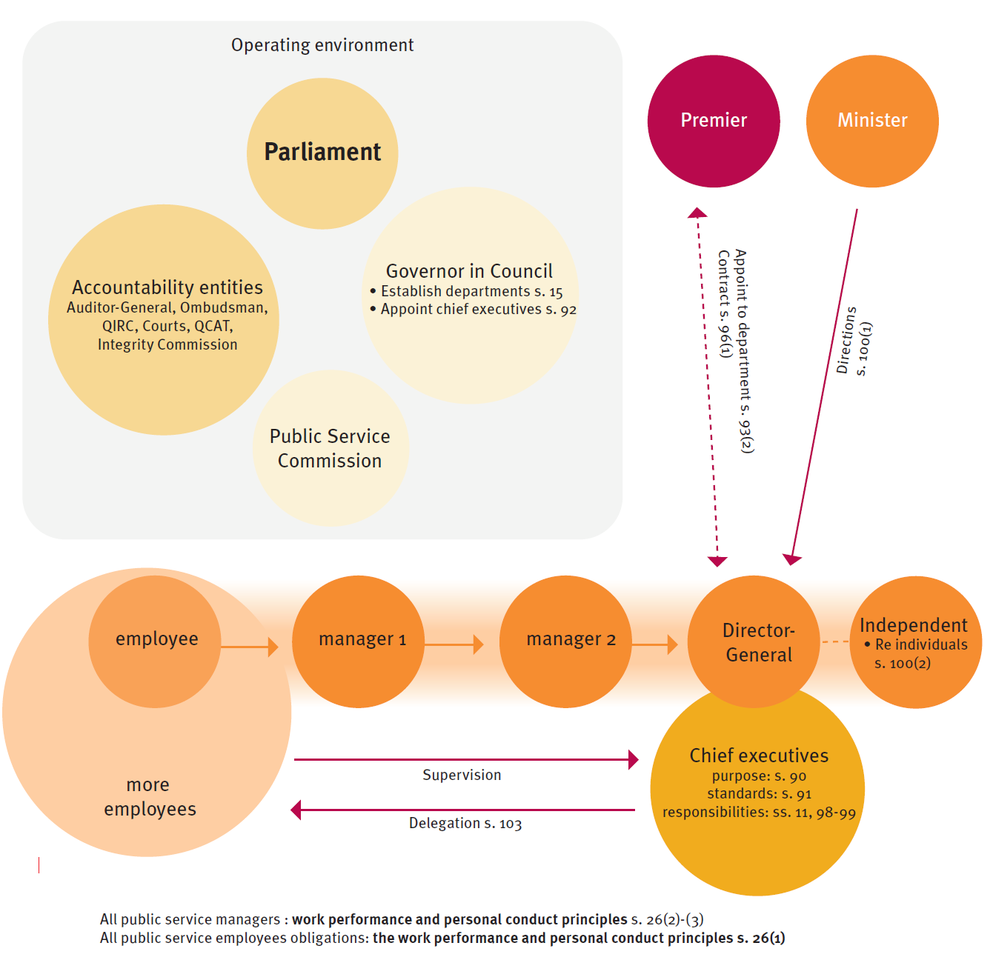

Some of the principles in section 26 are negatively framed. A positive performance framework might facilitate fairness.

1. Does section 26 of the Public Service Act adequately express the responsibilities of employees and their managers?
2. Could these responsibilities be framed more positively?

### Human resource management for agencies

The Act is silent about the human resource management (HRM) function of agencies. The importance of HRM is mentioned three times: in section 3(2)(b)(i) as a role of the Public Service Commission; section 25(2)(a) where best practice HRM is an abstract objective of employment, one of the management and employment principles; and section 46(1)(a), charging the commission with enhancement of human resource management capacity.

An HR function exists in almost every agency (some are shared), but it is difficult to define. HR functions might include:

* maintenance of personnel records
* the systems managing individual entitlements such as leave and payroll
* coordination of recruitment, selection, training and development, performance appraisal, and separation
* managing, or assisting management of investigations, discipline and poor performance management, and complaints and grievances
* providing advice on HR matters to employees, managers and the chief executive
* reporting on employment matters (e.g., diversity, employment statistics, annual leave)
* code of conduct and HR policy and standards
* workforce planning
* organisational change management.

Every big organisation, whether private, public or community sector, must have an adequately resourced ‘back room’ – the stewards of good governance who manage resources and support decision makers, as illustrated in *Figure 4 Three role types of public employees* on page 29.

These are the HR, finance, ICT, procurement and other professionals without whom actual delivery would be impossible, and responsiveness, especially to community and business, impacted negatively as frontline staff are diverted to fill the gaps or as wastage increases.

Reduction of an apparently “bloated bureaucracy” is an oft repeated demand of critics of government and, of course, efficiency is a real thing that needs to be worked at: the emphasis is rightly on service delivery and strategic direction. But there is no precise science specifying how many people are needed for good administration and what proportion of budget is reasonable or necessary for corporate areas. There are important reasons for increased accountability in the public sector with its role as steward of taxpayer money and power to make decisions. That has implications for the investment in administration.

Recent years have seen a reduction in the proportions dedicated to corporate activity in Queensland.

The Bligh Government’s machinery of government changes reduced the number of departments to 13 and reduced non-frontline employment by 3500 through voluntary separation.

The Newman Government’s ‘one Minister one department’ policy unpicked that structure, creating 19 departments. Subsequent “fiscal repair initiatives” reduced employment by about 14,000, including many from corporate areas.[97]

The Palaszczuk Government has seen growth in the public workforce in demand driven frontline services, predominantly in health and education. There has been proportionate growth in corporate areas that support these frontline services.

The *Financial Accountability Act 2009* provides specifically for accountable officers to be supported by a chief financial officer.

Stakeholders are divided over whether the chief human resource manager network should have parallel roles of chief financial officers, sounding cautionary notes about the breadth of human resource functions and the lack of specificity of a human resource management standards compared to accounting standard;[98] the relative strengths of occupational accreditation for human resource management and financial management; the diffuse character of human resource management issues compared with financial management; the less tangible character of HR performance and information.

Senior stakeholders expressed a preference for process or procedural support mechanisms over institutional form.

### Senior executives and senior officers; section 122 contracts

A service-within-a-service is established for senior executives by section 105 of the *Public Service Act 2008*. The Senior Executive Service (SES) employees are appointed by the Public Service Commission chief executive[99] on a contractual basis[100] for a term not longer than five years.[101] The contract is terminable by the State, and the executive may resign, on one month’s notice.[102] Contracts are renewable at the State’s discretion.

Contracts made under section 122 may also be used to employ people at higher remuneration.

The Senior Executive Service is intended to create a service-wide perspective and executive mobility.[103]

Chief executives, senior executives, senior officers and section 122 employees do not have industrial rights, and chief executives, senior executives and section 122 employees are not able to seek judicial review.[104]

The Senior Executive Service is subject to formal establishment control by the Governor-in-Council fixing the number of senior executives in each department and their classifications under section 109 of the Act.

Stakeholders indicate that senior executive mobility remains an issue despite recent improvements and say more could be done to achieve a service-wide perspective.

Some stakeholders were concerned that contracts by their nature were discouraging frank and fearless advice, but others considered the term of appointment a secondary issue, or even facilitative of executive level workforce renewal.

Fixing the number of senior executives (that is, persons) under section 109 discourages part-time employment and job sharing, raising a gender equity issue.

Several senior stakeholders observed that deputy directors-general were more content-focused than previously, less likely to be mobile and therefore less likely to develop as potential chief executives.

Establishment control of senior executives was said to lead to greater use of section 122 contracts that are not so tightly managed.

As at June 2018, the approved SES establishment across the Queensland public service was 459 of which 319 positions were occupied.[105] There are an additional 85 Senior Executives appointed under the *Hospital and Health Boards Act 2011* and 31 SES-equivalent roles in the Queensland Fire and Emergency Services and Queensland Police Service, appointed under the respective legislation for these entities.

There are an additional 439 SES-equivalent positions across the Queensland public service appointed through section 122 contracts, the vast majority (414 positions) in government departments.[106] The largest groupings of SES-equivalent employees on section 122 contracts include:

* Department of Education: 100
* Department of Natural Resources, Mines and Energy: 69
* Department of Transport and Main Roads: 47
* Department of Housing and Public Works: 47
* Department of State Development, Manufacturing, Infrastructure and Planning: 39.

The size of the SES cohort is primarily a matter for another review. For the purposes of this review, however, it is sufficient to note that employment through section 122 of the *Public Service Act 2008* is managed differently from the Governor-in-Council-approved SES establishment for the Queensland public service.

Some senior executive roles are not inherently about sector leadership but in recognition of market demands for specialised skills and should logically be section 122 contracts rather than senior executive roles.

Some stakeholders thought a separate “professional executive” might bring better balance, but others thought that would lead to splintering of capability and reduce mobility overall.

1. How should the senior executive and section 122 cohorts be administered?
2. What can be done to improve executive mobility and development of a stronger service-wide perspective among executives?

As at June 2018, there were 1620.5 FTE in the Senior Officer (SO) cohort across the Queensland public service. More than two thirds of these are employed in just six departments.

Senior Officers are tenured employees but without industrial rights. The *Public Service Act 2008* states these positions are intended to be a pool for potential senior executive appointment.

The position was created when the former classification SES1 was abolished.

1. Should the Senior Officer position be retained? If not, what changes should be made to ensure fairness to existing Senior Officers?

### Chief executive

“It’s lonely at the top.”[107]

A service-within-a-service is established for chief executives by *Public Service Act 2008* section 89.

The chief executive service consists of the heads of the government departments, appointed by the governor in council,[108] and assigned by the Minister (Premier) to a specific department,[109] engaged on contracts for up to five years.[110] The contractual basis is similar to that for senior executives, including a maximum five years term, renewability, and termination on one month’s notice

Chief executives, mostly called **Director-General**, but also called **Under Treasurer** and **Commissioner**, are responsible for running their departments. The chief executive is responsible for employment of public service employees in the department, on behalf of the State.[111]

A chief executive’s functions, stated in section 98 of the Act, are in addition to any portfolio specific responsibilities.

The Director-General Department of Education is responsible for all employment matters in that huge department but also for functions under other portfolio Acts, e.g., the power to exclude students from a State school under section 298 of the *Education (General Provisions) Act 2006*.

The concept of the Chief Executive Service suggests a shared experience and common scale of responsibility, but there are stark differences resulting from the scale of operations.

The Director-General for the Department of Health is responsible as system manager for a workforce of almost 90,000 FTE[112] and a budget of $17 billion.

The Director-General responsible for local government has a direct workforce of 188 FTE and a budget of $436 million, most of which goes directly to local governments through grants. The local government workforce, in excess of 37,000 FTE and budget in excess of $10 billion[113] are managed by each local government.

The Director-General for the Department of Aboriginal and Torres Strait Islander Partnerships has a workforce of 320 FTE and a budget of $86 million.

Heads of public services offices have the same authority for their agencies as chief executives do for their departments.[114]

Departmental Ministers may direct chief executives in managing the department but only generally and not about particular individuals.

In practice, chief executives, especially in large departments, delegate the hands-on task of management, often to a particular position or to a class of position. For example, a public service manager on a stated classification or higher might be delegated power to approve taking recreation leave.[115]

The delegation power in section 103 of the *Public Service Act 2008* is important because it allows delegation under other Acts:

**103 Delegation**

(1) A chief executive may delegate the chief executive’s functions under an Act to any appropriately qualified person.

(2) A delegation of a function may permit the subdelegation of the function.

(3) If the function is performed under another Act, the power to delegate or subdelegate is subject to the other Act.

For example in education, the chief executive has separate power to delegate under the *Education (General Provisions) Act 2006,* section 432.

The concentration of employment responsibility and authority in the hands of the chief executive reflects the essentially top down nature of Westminster public administration and is also mirrored in the *Financial Accountability Act*’s assignment of financial responsibility to chief executives as ‘accountable officers’.

Stakeholders have raised how chief executives can most effectively distribute their authority through delegation while still being responsible for the way power is used under delegation.

1. Are there mechanisms that can improve the support chief executives receive in discharging their employment responsibilities?

### Public Service Commission

The central personnel function under the *Public Service Act 2008* lies with the Public Service Commission (PSC).

**Members**. The Commission has four members: an independent chair (currently vacant) and, *ex officio*, the Director-General, Department of the Premier and Cabinet, the Under Treasurer, and the Commission’s chief executive.[116]

**Functions**. The Commission’s main functions are stated in section 46, and the Commission chief executive’s functions in section 58:

**46 Main functions of the commission**

(1) The commission’s main functions are to do the following—

(a) enhance the public service’s human resource management and capability;

(b) promote the management and employment principles;

(c) enhance and promote an ethical culture and ethical decision-making across the public service;

(d) enhance the public service’s leadership and management capabilities in relation to disciplinary matters;

(e) conduct commission reviews;

(ea) conduct reviews under part 6 about the handling by departments of work performance matters;

(f) develop and implement public service-wide workforce management strategies;

(g) together with the departments responsible for public sector industrial relations and public sector financial policy, consider improvements in the performance of departments through remuneration and conditions of employment;

(h) facilitate the purposes of the chief executive and senior executive services and the position of senior officer;

(i) report, at least annually, to the Minister on the application of the management and employment principles within the public service, including reporting on the following—

(i) the application of the principles, as a whole, within the public service as a whole;

(ii) the application of only 1 or more of the principles within the public service as a whole or a part of the public service;

(iii) the application of 1 or more of the principles for a specific purpose or to a specific group of persons;

(j) monitor, and report to the Minister about, the workforce profile of the public service;

(k) advise the Minister about the need for commission reviews about particular matters;

(l) promote a culture of continuous improvement and organisational performance management across all public service offices;

(m) provide a best practice advisory role on public service management, organisational performance management and workforce practices.

(2) In performing its functions, the commission must have regard to the management and employment principles.

(3) In this section—

workforce profile means the demographic categories and other characteristics of a workforce.

**58 Main functions of the commission chief executive**

(1) The commission chief executive is responsible for the performance of the commission’s functions.

(2) The commission chief executive’s other main functions are to do the following—

(a) approve final reports for commission reviews;

(b) make rulings;

(c) appoint and second senior executives;

(d) facilitate the development of senior executives and senior officers;

(e) perform other duties as directed by the Minister.

### What should the central human resource agency do

“It’s all about leadership”*[117]*

The Public Service Commission (PSC) has mixed administrative and leadership roles, primarily for the public service. The commission’s annual report lists the following activities:

* Business Services
* Capability Blueprint Program
* Communications and Engagement
* Community Insights
* Conduct and Performance Excellence
* Executive Recruitment and Contracts
* Leadership and Capability
* Leadership Talent and Performance
* Legislation and Policy
* Performance Analytics
* Workforce Strategy.

The Director-General of Queensland Health is the system manager for the public health system. In that capacity the Director-General also has a central human resources agency function for approximately 90,000 fulltime equivalent employees.

**Other jurisdictions**

See Attachment 4.7 – Central human resource agencies – for an overview of the central personnel functions of other jurisdictions. All are operating in a devolved management environment with varying degrees of central authority and structures including single commissioners, multiple commissioners, boards, advisory boards, departmental structures and external independence.

1. What should the scope and structure of the central human resource agency be?
2. Should that central agency have wider responsibilities for:  
   (a) public sector-wide management and performance standards; and  
   (b) professional development and skills of public service managers below executives?

### Good governance

The Public Service Commission is only one of three central agencies traditionally responsible for overall system management and public employment. The others are Department of the Premier and Cabinet for policy, and Queensland Treasury for finance.

1. What role should the Public Service Commission have in fostering leadership in the public sector?
2. How can overall good governance, to include all relevant central agencies be addressed in the Act?

### Industrial relations

While public service employees are employees for industrial relations purposes,[118]the Public Service Commission does not manage public sector industrial relations. That is a function under the Minister for Industrial Relations, and currently housed (on a portfolio basis) in the Department of Education: the Office of Industrial Relations under a Deputy Director-General. The office’s remit is far wider than the public service.[119]

1. How might the Public Service Act facilitate stronger exchange of information and strategic issues management between the Public Service Commission, the public health system manager and the Office of Industrial Relations?

### Departmental Ministers and the Premier

The minister overseeing the public service is the Premier, whose relevant responsibilities are:[120]

|  |  |
| --- | --- |
| Principal Ministerial Responsibilities | Overall public service management and employment conditions to ensure the development of a highly professional public service  Senior Executive Service |
| Acts administered | *Public Sector Ethics Act 1994*  *Public Service Act 2008* |
| Administrative unit | Public Service Commission |
| Responsible Head | Commission chief executive |

The Premier’s functions as minister for the *Public Service Act 2008* are stated in section 38(1):

**36 Minister’s role for the public service and public service offices**

(1) The Minister has the following functions—

(a) to promote the overall effectiveness and efficiency of the public service;

(b) to assess the appropriateness, effectiveness and efficiency of public service management, and in particular, departments or parts of departments;

(c) to advise departmental Ministers about steps that should be taken to improve the public service’s effectiveness and efficiency;

(d) to authorise reviews of activities or functions of public service offices;

(e) to refer to the commission for review matters relating to the effectiveness or efficiency of public service offices;

(f) to monitor the performance of the commission’s functions.

The Premier is the contracting party for the State for chief executives’ contract of employment, and may also:

* refer matters to the commission for review into effectiveness and efficiency (section 39)
* authorise a review of a public service office (section 40; review conducted under section 41)
* direct that a department’s chief executive take action about surplus staff (section 42)
* require information be given about a review being undertaken by the commission (section 81)
* make standards about how the chief executive service operates (section 91)
* once the Governor-in-Council has appointed a person as chief executive, appoint the chief executive to a department (section 93).

In addition, the Governor-in-Council (acting on advice of the Premier as administering minister) has powers, including to:

* establish departments, entities in departments and departmental functions (sections 14–17)
* appoint chief executives (section 92) and terminate the appointment (section 97)
* fix the number of senior executives and their classification for a department, commonly called “establishment control” (section 109).

Departmental ministers may direct their chief executives about surplus employees (section 42); management of the department but not about particular individuals (section 100); and the resolution of conflicts of interest (section 102).

Responsiveness to government is primarily about how the Premier and other Ministers can be assured the public service is giving the best possible support to the government-of-the-day and helping the government’s agenda.

1. Does the Public Service Act need to be changed to improve the public service’s ability to respond effectively to Government direction and to provide high level policy support?

## Public sector ethics

Public service involves a level of special trust: employees are doing the work of government and in the context of government. Employees are stewards of public resources and are sometimes given considerable power over others.

The *Public Sector Ethics Act 1994* originally stated ethical principles drawn from the Electoral and Administrative Review Commission “Report on the review of codes of conduct for public officials”. The Act was significantly amended in 2010.

Attachment 4.9 shows the ethical principles as originally passed and as amended in 2010.

As a general observation the ethical principles could be more widely understood by public employees and better integrated into induction and ongoing professional development.

Stakeholders have expressed mixed views about the utility of the principles, some preferring the original set; others the 2010 set; and others still opining that the principles are of limited practical use.

The Act sits alongside other integrity and ethics related matters including:

* *Public Interest Disclosure Act 2010*
* Queensland Public Service Code of Conduct
* Queensland Public Service values
* Integrity Commissioner.

The intersection between the *Public Sector Ethics Act 1994*, the Code of Conduct and the public service values[121] is a congested space. Factor in the transparency and accountability requirements around disclosure of interests, gift registers, contact with lobbyists, restrictions on employment post-separation, right to information, public records obligations and the field becomes even more congested and harder for even experienced participants to navigate. Public interest disclosures[122] in particular appear to be very poorly-understood.

1. Can the various elements that seek to guide ethical decision-making in the Queensland public sector fit together?

# Other stakeholder input

### Complaints

The Queensland public sector already operates a mandated complaints system,[123] an essential part of any democracy through which clients of government services are able to offer feedback on their experience which can support service improvement, and for employing agencies to give feedback on the employment experience.

There are, however, a number of concerns about the system’s operation. Management and employee representatives both expressed concern that some customer complaints are vexatious or frivolous, diverting time and effort from service delivery and cause uncertainty in employment relationships. In some areas, complaint management can be very onerous because of the risks and implications inherent in the service area, such as child protection or school management.

The challenge is to maintain a meaningful complaint system that can drive responsiveness and change while discouraging or better managing vexatious and frivolous complaints.

1. How should the Public Service Act deal with vexatious and frivolous complaints?

### Resourcing special projects

Stakeholders have raised resourcing in several different ways.

First, stakeholders noted that the public sector is often asked to take on new challenges or develop initiatives without extra resources or reprioritising workloads. Employee representatives were concerned about how they can be responsive when the demands on frontline staff continue to increase.

Second, it has also been suggested that the sector requires greater flexibility in identifying and deploying resources collaboratively to deal with specific issues or to get initiatives up and running.

Third, senior managers have stated that managing across departmental boundaries can be time-consuming and difficult. The context of the comment was about both inter-agency projects and services and new, flexible work that might see an employee having two or more part-time roles in different agencies.

These are aspects of a governance dilemma: how to operate the public sector as a coherent system. Deploying people and assets within one portfolio can be difficult but it is manageable. Deploying people and assets among and between multiple entities is more problematic. One recent successful example was resourcing the Commonwealth Games Corporation. Directors-General collaborated to support the establishment of the Office of the Commonwealth Games (OCG) through a targeted secondment program. The objective of the program was to match existing employees with the right talents and development needs to the business needs of the OCG. Some 53 employees from 16 different agencies were seconded to the OCG through this program, with sponsoring agencies funding the salary of the seconded officers.

1. How can the Public Service Act support a collective approach to system governance?

### Public servants on government boards

Many entities are created under special legislation to enable them to operate at arms-length from government. For many such entities, though, public servants are often board members, some appointed *ex officio* and some nominated by a Minister or a Chief Executive. Having public servants on these boards has traditionally been viewed as sound governance and a way to achieve a sensible balance between operational independence and ensuring effective portfolio support.

However, public service representation on boards can actually create a conflict of interest and can make it harder for the department to provide effective support to the board as and when it is needed. The Commonwealth’s Uhrig Review of 2003-04 found that:

…while these types of appointments are appropriate for advisory boards, for governance boards they fail to produce independent, critical and objective thinking. Representational boards do not provide the best form of governance for an authority due to the potential for directors to be primarily concerned with the interest of those they represent, rather than the success of the entity they are responsible for governing.[124]

The review of Queensland Government boards briefly examined the issue of public servants as members of government boards.[125] The final recommendation was to avoid *ex officio* appointments and observer status, and that public servants should be sensitive to certain issues.[126]

1. Are there changes needed to clarify the ethical and other considerations for public employees on government boards?

# Attachments

## Public employment pathways

|  |  |
| --- | --- |
| **Office or officer** | **Act** |
| 1. **Public Service** | |
| Public service employees:   * Public service officers   + chief executives   + senior executives   + other types of officers * Other public service employees   + general employees   + temporary employees   *See 8 below for employees under public service offices*  *See 10 below for anomalous arrangements*  Services within the public service are:   * chief executive service * senior executive service | *Public Service Act 2008* |
| 1. **Separate services** | |
| Queensland Ambulance Service:   * Ambulance service officers | *Ambulance Service Act 1991* |
| Queensland Police Service, consisting of police officers, police recruits and staff members.   * A police officer, police recruit or special constable are employed under the Police Service Administration Act. * Staff members under the Commissioner (civilian employees of the Police Service) are under the PS Act | *Police Service Administration Act 1990* |
| Queensland Fire and Emergency Services:   * Commissioner * Fire Service officers | *Fire and Emergency Services Act 1990* |
| Queensland Parliamentary Service:   * Officers and employees of the Parliamentary Service * Parliamentary Crime and Corruption Commissioner | *Parliamentary Service Act 1988*  *Crime and Corruption Act 2001* |
| Hospital and Health Services:   * A health service employee (subject to an applied Public Service law)   A separate health executive service exists.  All 16 HHSs may employ health executives and senior health service employees.  Eight individual health executive services are by regulation empowered to employ other staff: Children’s Health Queensland, Gold Coast, Metro North, Metro South, North West, Sunshine Coast, Townsville and West Moreton. The other eight services employ staff through the Director-General, Queensland Health | *Hospital and Health Boards Act 2011* |
| * Ministerial staff * Staff of the Leaders of the Opposition * Staff of the leader of a non-government party * Staff of an Independent Member   Staff are employed by the chief executive of the administering department (Premier and Cabinet) and are subject to the IR Act (see s. 11) | *Ministerial and Other Office Holder Staff Act 2010* |
| 1. **Entire public sector functions** | |
| Ombudsman  Acting Ombudsman  A person seconded to the Ombudsman Office  Employees of the Ombudsman | *Ombudsman Act 2001* |
| Members of the Legal Aid Board  Chief executive officer of Legal Aid  Employees engaged by Legal Aid | *Legal Aid Queensland Act 1997* |
| Crime and Corruption Commissioners; chief executive officer  Senior officers of the CCC (whose duties in the opinion of the Chair equate to SES)  Staff of the CCC  Persons engaged temporarily to provide services, information or advice to the CCC  Public Interest Monitor | *Crime and Corruption Act 2001* |
| Workcover chief executive  Workcover senior executives  Executive officer of the employing office  Employees of the employing office  (The Workers’ Compensation Regulator is under the PS Act) | *Workers’ Compensation and Rehabilitation Act 2003* |
| Chief executive officer of the authority  Executive officer of the employing office  Staff of the employing office | *Residential Tenancies and Rooming Accommodation Act 2008* |
| Chief executive officer of the Authority  Authority employees | *Rural and Regional Adjustment Act 1994* |
| Queensland Building and Construction Commission - commissioner, executive officer and employees of the office | *Queensland Building and Construction Commission Act 1991* |
| Commissioners and staff of the Commission | *Queensland Productivity Commission Act 2015* |
| National Injury Insurance Agency, Queensland, board members, chief executive and staff | *National Injury Insurance Scheme (Queensland) Act 2016* |
| Cross River Rail Delivery Board appointed members, chief executive and staff | *Cross River Rail Delivery Act 2017* |
| Members of the governing board of TAFE Queensland  the chief executive officer of TAFE Queensland  staff employed by TAFE Queensland to perform its functions | *TAFE Queensland Act 2013* |
| 1. **Judicial, investigatory etc** | |
| Department adjudicator or conciliator appointed under contract (s. 236(3)) | *Body Corporate and Community Management Act 1997* |
| Mediator | *Dispute Resolution Centres Act 1990* |
| Director of Public Prosecutions  Deputy Director of Public Prosecutions | *Director of Public Prosecutions Act 1984* |
| Disciplinary board members | *Racing Act 2002* |
| Associates to judges (excluded by s. 13(2)  Bailiffs | *District Court of Queensland Act 1967* |
| Tribunal members | *Queensland Independent Remuneration Tribunal Act 2013* |
| Magistrates (excluded by PSA s. 13(b))  Judicial Registrars  A Clerk of the Court acting as Magistrate or as judicial registrar *pro tem* | *Magistrates Act 1991* |
| Members of the Mental Health Review Tribunal  Assisting Psychiatrist (Mental Health Court) | *Mental Health Act 2016* |
| Solicitor-General  Acting Solicitor-General *pro tem* | *Solicitor-General Act 1985* |
| Principal registrar, other registrars and officers  Sheriff of Queensland, deputy sheriffs and bailiffs  Associates to the judges of the Court | *Supreme Court of Queensland Act 1991* |
| Assessors  Members of the QCAT  Adjudicators  A QCAT justice of the peace | *Queensland Civil and Administrative Tribunal Act 2009* |
| Mental Health Commissioner | *Queensland Mental Health Commission Act 2013* |
| Land Tribunal members | *Aboriginal Land Act 1991* |
| Appointed members of the parole board | *Corrective Services Act 2006* |
| Public interest monitor | *Police Powers and Responsibility Act 2000* s. 740 |
| Associates to the President, Vice-President or other members of the Commission | *Industrial Relations Act 1999* |
| 1. **Commercial focus or major events** | |
| CEO of Tourism and Events Queensland | *Tourism and Events Queensland Act 2012* |
| Staff of Stadiums Queensland | *Major Sports Facilities Act 2001* |
| Chief executive  Executive officer of the employing office  Employees of the employing office | *South Bank Corporation Act 1989* |
| Gold Coast 2018 Commonwealth Games Corporation CEO and staff | *Commonwealth Games Arrangements Act 2011* |
| Commonwealth Games Infrastructure Authority - non-ex officio members of the Authority | *Economic Development Act 2012* |
| Community Enterprise Queensland chief executive | *Aboriginal and Torres Strait Islander Communities (Justice, Land and Other Matters) Act*  *1984* |
| 1. **Advisory roles** | |
| Independent members of the Board of Trade and Investment Queensland | *Trade and Investment Queensland Act 2013* |
| Members, Jobs Queensland | *Jobs Queensland Act 2015* |
| 'other staff;' employed by the Queensland Agricultural Training Colleges | *Queensland Agricultural Training Colleges Act 2005* |
| Mining safety and health advisory committee members who are not inspectors  District workers representatives | *Mining and Quarrying Safety and Health Act 1999* |
| Coal mining safety and health advisory committee members who are not inspectors | *Coal Mining Safety and Health Act 1999* |
| Members of the Persons Affected by Work-related Fatalities and Serious Incidents Consultative Committee | *Work Health and Safety Act 2011* |
| 1. **Oversight or management bodies of PS functions** | |
| Queensland Competition Authority members | *Queensland Competition Authority Act 1997* |
| Family Responsibilities Commission and Board members | *Family Responsibilities Commission Act 2008* |
| Members of the Authority  Executive Director of the Office of the Prostitution Licensing Authority | *Prostitution Act 1999* |
| Queensland Family and Child Commissioners | *Family and Child Commission Act 2014* |
| Board members | *Queensland Art Gallery Act 1987* |
| Board members | *Queensland Museum Act 1970* |
| Queensland Performing Arts Trust (board) members | *Queensland Performing Arts Trust Act 1977* |
| Board members | *Queensland Theatre Company Act 1970* |
| Board members | *Libraries Act 1988* |
| 1. **Independent statutory officers discharging public functions**   **where staff generally are under the PS Act** | |
| Auditor-General  Contract auditors | *Auditor-General Act 2009* |
| RTI Commissioner  Acting RTI Commissioner | *Right to Information Act 2009* |
| Anti-Discrimination Commissioner | *Anti-Discrimination Act 1991* |
| Privacy Commissioner  Acting Privacy Commissioner *pro tem* | *Information Privacy Act 2009* |
| Health Ombudsman | *Health Ombudsman Act 2013* |
| Inspector-General of Emergency Management | *Disaster Management Act 2003* |
| Energy and Water Ombudsman  Acting Energy and Water Ombudsman *pro tem* | *Energy and Water Ombudsman Act 2006* |
| Public Guardian  A community visitor (adult)  A community visitor (child) | *Public Guardian Act 2014* |
| Secretary and other officers of the Valuers Registration Board of Queensland | *Valuers Registration Act 1992* |
| Chief operating officer of the Agency | *Public Safety Business Agency Act 2014* |
| Public Trustee | *Public Trustee Act 1978* |
| An indigenous assessor  A judicial registrar | *Land Court Act 2000* |
| Members of the Law Reform Commission | *Law Reform Commission Act 1968* |
| Legal Services Commissioner  An investigator who is not staff of the Legal Services Commission | *Legal Profession Act 2007* |
| The Parliamentary Counsel | *Legislative Standards Act 1992* |
| Integrity Commissioner | *Integrity Act 2009* |
| Agent-General for Queensland | *Agent-General for Queensland Act 1975* |
| Commissioners  Chief executive officer | *Gasfields Commission Act 2013* |
| Director of Mental Health | *Mental Health Act 2016* |
| Director of Forensic Disability | *Forensic Disability Act 2011* |
| Principal Commissioner and Commissioner | *Family and Child Commission Act 2014* |
| Appointed Commissioner  Senior electoral officer | *Electoral Act 1992* |
| Director of Child Protection Litigation | *Director of Child Protection Litigation Act 2016* |
| Land access ombudsman | *Land Access Ombudsman Act 2017* |
| Training ombudsman | *Further Education and Training Act 2014* |
| Racing Integrity commissioner and deputy commissioners | *Racing Integrity Act 2016* |
| 1. **Specialised roles not normal PS functions** | |
| SPER debt collectors | *State Penalties Enforcement Act 1999* |
| Animal valuers | *Criminal Code (Animal Valuers) Regulation 2014* |
| A lawyer appointed to help the chief executive for an expungement application | *Criminal Law (Historical Homosexual Convictions Expungement) Act 2017* |
| Race day stewards | *Racing Integrity Act 2016* |
| Mediators appointed under the Act | *Retail Shop Leases Act 1994* |
| Adjudicators appointed under the Act | *Building and Construction Industry Payments Act 2004* |
| 1. **Statutory offices excluded and with anomalous power to appoint outside PS Act** | |
| The Act does not specifically exclude the Coordinator-General (CG) and the Deputy CG from the Public Service Act, but appears to do so by necessary intent  A person appointed by the CG to help the CG in the performance or exercise of his or her functions or powers. The CG must consult with the Commission Chief Executive (CCE) in appointing such a person (s. 14) | *State Development and Public Works Organisation Act 1971* |
| Chief executive of the Authority  An officer appointed by the chief executive to assist in performance of duties etc (subject to consultation with the CCE): s.24  Authority staff are under the PS Act | *Queensland Reconstruction Authority Act 2011* |
| Chief executive officer  Employees employed by the chief executive under s.65 “necessary to perform the Authority’s functions)  Employees not appointed under s.65 are appointed under PS Act | *Gold Coast Waterways Authority Act 2012* |
| Agents engaged to meet temporary circumstances of the Public Service Commission (s. 79) | *Public Service Act 2008* |

## Provisions of *Public Service Regulation 2018*



## Type of appointment

Type of appointment

Sch. 4

***appoint***, a person as a public service officer, means—

1. for a person who is not already a public service officer—employ the person as an officer; or
2. for a public service officer—promote, transfer or redeploy the officer.

|  |  |  |
| --- | --- | --- |
| **Term** | **Source** | **Meaning** |
| the public service | s. 5 | The **Queensland Public Service** consists of the persons who are employed under this Act, called **public service employees** |
| public service employees | s. 6 | **Public service employees** are employed in departments or public service offices |
| public service officers | s. 8 | A person is a **public service officer** if the person is employed under this Act as—  (a) a chief executive; or  (b) a senior executive; or  (c) an officer of another type.[127] |
| public service employee | s. 9(1) | A person is a **public service employee** if the person is employed under this Act as—  (a) a public service officer; or  (b) a general employee; or  (c) a temporary employee. |
| departmental employee | s. 90(3) | **departmental employees** means public service employees employed in the chief executive’s department |
| non-executive employee  limit on industrial relations Minister’s power to make rulings | s. 54(4) | ***non-executive employees*** means public service employees other than—  (a) chief executives, senior executives or senior officers; or  (b) other public service officers on contract whose remuneration is equal to, or higher than, the remuneration payable to a senior officer. |
| State employee  for attachment of civil liability to the State to another entity under s. 26C | s. 26B | (1) This division applies to each of the following—  (a) a public service employee;  (b) a ministerial staff member within the meaning of the Ministerial and Other Office Holder Staff Act 2010;  (c) a person mentioned in section 13(2); [excluded offices]  (d) a person appointed under an Act (other than this Act) if the appointment involves the person acting for or representing the State;  (e) a person who is not a public service employee but who is a member or employee of a government entity that represents the State;  (f) a person (other than a public service employee) to whom a function or power of a person mentioned in paragraph (a), (d) or (e) is delegated under an Act;  (g) another person prescribed by regulation as a State employee.  (2) Also, this division applies to a person who was a person of the type mentioned in subsection (1) at the time the person engaged in conduct in an official capacity.  (3) Despite subsections (1) and (2), this division does not apply to the following—  (a) a person who is the holder of an office mentioned in section 13(1); [excluded offices]  (b) a person to whom the Police Service Administration Act 1990, section 10.5 applies; [analogous provision for police officers]  (c) a person employed in or appointed by—  (i) a GOC; or  (ii) a subsidiary of a GOC under the Corporations Act; or  (iii) a government entity within the meaning of the Government Owned Corporations Act 1993 declared by regulation under that Act to be a subsidiary of a GOC; or  (iv) a government company within the meaning of the Government Owned Corporations Act 1993, section 2 ;  (d) another person prescribed by regulation as a person who is not a State employee, including a person to whom this division would otherwise apply because of subsection (1) (d), (e) or (f).  (4) A person to whom this division applies is a "**State employee**". |
| employee  for EEO matters | s. 30(4) | **employees** means individuals appointed or engaged—  (a) under a contract of service, whether on a full-time, part-time, permanent, casual or temporary basis; or  (b) under a statutory appointment |
| general employee | s. 147 | (1) A chief executive may employ a person as a general employee to perform work of a type not ordinarily performed by a public service officer  (2) The employment may be—  (a) on tenure, or on a temporary basis and full-time or part-time; or  (b) on a casual basis.  (3) A person employed under this section does not, only because of the employment, become a public service officer |
| temporary employee | s. 148;  s. 149(5) | (1) To meet temporary circumstances, a chief executive may employ a person as a temporary employee to perform work of a type ordinarily performed by a public service officer other than a chief executive or senior executive.  (2) The employment may be—  (a) on a temporary basis and full-time or part-time; or  (b) on a casual basis  Temporary employees (including temporary general employees) may have their employment converted to permanent in certain circumstances: s. 149 |
| casual employee | not defined in the Act  general law; industrial instruments | *Industrial Relations Act 2016*:  ***casual employee*** means an employee who is employed more than once by the same employer over a period (s. 71HI)  ***long term casual employee*** is a casual employee engaged by a particular employer, on a regular and systematic basis, for 1 or more periods of employment during the 1 year immediately before the employee seeks to access an entitlement under this chapter (s. 15)  Casual employees may have their employment converted to permanent in certain circumstances: s. 149A |
| temporary general employee  for transition provision only | s. 272 | ***temporary general employee*** means a person who is a general employee—  (a) employed on a temporary basis; and  (b) not employed on a casual basis. |
| service with the State  and  office of service with the State  (for re-employment after unsuccessfully contesting an election) | s. 129  s. 130  (not defined or otherwise described) | ***service with the State*** means employment, in any capacity in—  (a) the public service; or  (b) the police service; or  (c) any other office, position or place under the State.  ***the State*** includes a board, commission, commissioner, corporation, instrumentality or other person representing the State. |

Place and description of employment or role, employer, manager

|  |  |  |
| --- | --- | --- |
| **Term** | **Source** | **Meaning** |
| government entity | s. 24 | (1) An entity is a **government entity** if it is—  (a) a department or part of a department; or  (b) a public service office or part of a public service office; or  (c) an agency, authority, commission, corporation,  instrumentality, office, or other entity, established under an Act or under State authorisation for a public or State purpose; or  (d) a part of an entity mentioned in paragraph (c); or  (e) another entity, or part of another entity, declared under a regulation to be a government entity; or  (f) a registry or other administrative office of a court of the State of any jurisdiction.  (2) However, each of the following entities is not a ***government entity***—  (a) a local government;  (b) a corporation owned by a local government, or a subsidiary of a corporation owned by a local government;  (c) the parliamentary service;  (d) the Governor’s official residence (known as ‘Government House’) and its associated administrative unit;  (e) the Executive Council;  (f) the Legislative Assembly;  (g) a court of the State of any jurisdiction;  (h) the police service to the extent that it does not include staff members mentioned in the *Police Service Administration Act 1990*, section 2.5(1)(a);  (i) a school council established under the *Education (General Provisions) Act 2006* or a university established under an Act;  (j) a cooperative under the *Cooperatives Act 1997* for primary producers that is not in receipt of moneys of, or financial assistance from, the State;  (k) a government owned corporation, unless a regulation declares it to be a government entity;  (l) another entity, or part of another entity, declared under a regulation not to be a government entity. |
| department | s. 7 | A department is an entity declared under division 2 to be a department of government |
|  | s. 14  see also s. 15 | (1) The departments of government are the entities declared to be departments of government by the Governor in Council by gazette notice.  (2) A department of government includes the entities declared to be part of the department by the Governor in Council by gazette notice. |
| employing chief executive  for disciplinary action | s. 186A | ***employing chief executive,*** of a public service employee, means the chief executive of a department in which the employee holds an appointment or is employed after the employee changes from one department to another department. |
| designation; role | s. 98 | ***designation***, of a role, includes the title of the role and its organisational location within a department. |
| public service offices | s. 21 and sch. 1; regulation | (1) A ***public service office*** is—  (a) an entity that schedule 1 states is a public service office; or  (b) subject to section 23, another designated entity, or part of a designated entity, declared under a regulation to be a public service office.  See Appendix 4.5 for list of public service offices |
| public service offices | Modified meaning for the Minister’s [Premier’s] role: s. 35 | In this part, ***public service office***—  (a) includes—  (i) a department or part of a department; and  (ii) the police service; but  (b) does not include—  (i) the integrity commissioner; or  (ii) the office of the information commissioner; or  (iii) the audit office |
| Designated entity | s. 2413) | ***designated entity*** means an entity, or part of an entity, mentioned in section 24(1)(c), (d), (e) or (f) that is not an entity mentioned in section 24(2). |
| position | ss. 46(1)(h); 116; 177: senior officers  s. 121(2)(b): contract for fixed term | used about senior officers  (2) Appointment as a public service officer is on tenure unless—  (a) the officer’s chief executive decides the appointment may be on contract for a fixed term; and  (b) the chief executive declares the officer’s position to be available on contract for a fixed term |
| office | s. 13: Used for exclusion of certain offices from the Act | Act does not apply to particular offices and employment  (1) This Act does not apply to an office if—  (a) appointments to the office are made by the Governor alone; or  (b) the salary for the office is provided for under the *Judicial Remuneration Act 2007*, the *District Court of Queensland Act 1967* or the *Magistrates Act 1991*; or  (c) the office is a particular office established by an Act that expressly provides for the appointment of the holder of an office mentioned in paragraph (b); or  (d) the office is honorary. |
| statutory office | Sch. 4 | ***statutory office*** means an office established under an Act to which a person may be appointed only by the Governor in Council or a Minister. |
| EEO agency | s. 30(1) | Each of the following entities (a ***relevant EEO agency***) must act to promote EEO for employment matters that concern it—  (a) a government entity;  (b) the police service;  (c) an entity that another Act provides is a relevant EEO agency;  (d) an entity prescribed under a regulation. |
| Manager  For work performance and personal conduct principles: | s. 26 | (4)…**public service manager** means a public service employee whose duties involve or include managing other public service employees in the carrying out of their duties.  (2) Also, a **public service manager** must take all reasonable steps to ensure each public service employee under the manager’s management is aware of the following—  (a) the work performance and personal conduct expected of the employee;  (b) the values of the public service and of the department or public service office in which the employee is employed;  (c) what constitutes corrupt conduct under the Crime and Corruption Act 2001.  (3) Further, a public service manager must—  (a) pro-actively manage the work performance and personal conduct of public service employees under the manager’s management; and  (b) if a case of unacceptable work performance or personal conduct arises, take prompt and appropriate action to address the matter. |
| responsible person  for discipline | s. 187(4) | ***responsible person***, for a direction, means a person with authority to give the direction, whether the authority derives from this Act or otherwise. |

Basis of employment

|  |  |  |
| --- | --- | --- |
| **Term** | **Source** | **Meaning** |
| Basis of employment—tenure or contract | s. 121 | (1) A directive may provide for the circumstances in which a public service officer may be appointed on contract for a fixed term.  (2) Appointment as a public service officer is on tenure unless—  (a) the officer’s chief executive decides the appointment may be on contract for a fixed term; and  (b) the chief executive declares the officer’s position to be available on contract for a fixed term. |
| Basis of employment for contract employment | s. 122 | (1) This section applies if a public service officer’s appointment is to be on contract for a fixed term.  (2) The officer must enter into a written contract of employment with the officer’s chief executive. |
| Contract terminated on acceptance of tenure | s. 124 | (1) If a public service officer who is employed on contract accepts employment as a public service officer on tenure, the contract is taken to be terminated by agreement of the parties. |
| Full-time or part-time tenure | s. 125 | Appointment as a public service officer in a department on tenure may be on the basis of full-time or part-time employment, as decided by the officer’s chief executive |
| Appointment on probation | s. 126 | (1) This section applies if a person who is not already a public service officer is appointed as a public service officer on tenure.  (2) The officer’s chief executive may decide that the officer is appointed on probation for the following period from the appointment (the ***probationary period***)—  (a) generally—3 months;  (b) if the officer and the chief executive agree in writing before employment under the appointment to a longer period—the longer period.  (3) The longer period must be a reasonable period having regard to the nature and circumstances of the employment. |
| casual | s. 147 (general employees)  s. 148 (temporary employees) | See above  Casual employees may have their employment converted to permanent in certain circumstances: s. 149A |

Definitions form other statutes

Definition in *Cross River Rail Delivery Act 2016*

***government agency—***

(a) means—

(i) a department or an administrative unit within a department; or

(ii) a government owned corporation or a subsidiary of the corporation; or

(iii) an entity that is established under an Act and represents the State; or

(iv) an entity that is established under an Act, does not represent the State and is prescribed by regulation; or

(v) Stadiums Queensland established under the *Major Sports Facilities Act 2001*, section 5; or

(vi) the Queensland Rail Transit Authority or a subsidiary of the Authority; or

(vii) the Queensland Bulk Water Supply Authority established under the *South East Queensland Water (Restructuring) Act 2007*, section 6; or

(viii) a department, or an administrative unit within a department, of the government of the Commonwealth; or

(ix) a statutory body representing the Commonwealth; or

(x) the Brisbane City Council; or

(xi) a corporation owned by the Brisbane City Council; or

(xii) an entity that conducts a beneficial enterprise or business activity, within the meaning of the *City of Brisbane Act 2010*, in participation with or for the Brisbane City Council; but

1. does not include an entity mentioned in paragraph (a)(i), (ii), (iii), (viii), (ix), (xi) or (xii) prescribed by regulation.

## Queensland public sector agencies

### Departments – as listed on the Queensland Government website

1. Department of Aboriginal and Torres Strait Islander Partnerships
2. Department of Agriculture and Fisheries
3. Department of Communities, Disability Services and Seniors
4. Department of Child Safety, Youth and Women
5. Department of Corrective Services
6. Department of Education
7. Department of Employment, Small Business and Training
8. Department of Environment and Science
9. Department of Housing and Public Works
10. Department of Innovation, Tourism Industry Development and the Commonwealth Games
11. Department of Justice and Attorney-General
12. Department of Local Government, Racing and Multicultural Affairs
13. Department of Natural Resources, Mines and Energy
14. Department of State Development, Manufacturing, Infrastructure and Planning
15. Department of the Premier and Cabinet
16. Department of Transport and Main Roads
17. Public Service Commission
18. Queensland Corrective Services
19. Queensland Fire and Emergency Services
20. Queensland Health
21. Queensland Police Service
22. Queensland Treasury.

Note: the official names and structures of departments are in complicated documents called “public service departmental arrangements notices” published in the *Queensland Government Gazette*.

In addition to departments:

more than “*300 Queensland Government boards, committees and other government bodies with various roles and functions, such as:*

* *boards that oversee Hospital and Health Services;*
* *committees that advise Ministers on industry issues;*
* *tribunals that resolve disputes;*
* *foundations that administer donations for medical research; and*
* *professional registration boards*.”[128]

## Public service offices

Some of those bodies are staffed by public servants, the “public service offices” each headed by a statutory officer.

The following table is extracted from Schedule 1 of the *Public Service Act 2008* as at 31 August 2018.

|  |  |
| --- | --- |
| **Public service office** | **Head** |
| Anti-Discrimination Commission under the *Anti-Discrimination Act 1991* | anti-discrimination commissioner |
| audit office | auditor-general |
| Building and Construction Industry (Portable Long Service Leave) Authority under the *Building and Construction Industry (Portable Long Service Leave) Act 1991* | general manager |
| Building Queensland under the *Building Queensland Act 2015* | chief executive officer under the *Building Queensland Act 2015* |
| Electoral Commission of Queensland under the *Electoral Act 1992* | electoral commissioner |
| Family Responsibilities Commission Registry under the*Family Responsibilities Commission Act 2008* | the commissioner under the *Family Responsibilities Commission Act 2008* |
| Gold Coast Waterways Authority under the *Gold Coast Waterways Authority Act 2012* | chief executive officer under the *Gold Coast Waterways Authority Act 2012* |
| Industrial Registry under the *Industrial Relations Act 2016* | registrar |
| Land Tribunal under the *Aboriginal Land Act 1991* | chairperson of the tribunal |
| Mental Health Review Tribunal under the *Mental Health Act 2016* | president of the tribunal |
| Office of the Director of Child Protection Litigation under the*Director of Child Protection Litigation Act 2016* | Director of Child Protection Litigation |
| Office of the Energy and Water Ombudsman under the *Energy and Water Ombudsman Act 2006* | energy and water ombudsman under the *Energy and Water Ombudsman Act 2006* |
| Office of the Health Ombudsman under the *Health Ombudsman Act 2013* | health ombudsman |
| Office of the Independent Assessor under the *Local Government Act 2009* | Independent Assessor |
| office of the information commissioner | information commissioner |
| Office of the Inspector-General of Emergency Management under the *Disaster Management Act 2003* | Inspector-General of Emergency Management |
| Office of the Land Access Ombudsman under the *Land Access Ombudsman Act 2017* | land access ombudsman |
| Office of the Prostitution Licensing Authority under the *Prostitution Act 1999* | executive director |
| office of the public guardian under the *Public Guardian Act 2014* | public guardian |
| Office of the Queensland College of Teachers under the *Education (Queensland College of Teachers) Act 2005* | director of the office |
| Office of the Queensland Parliamentary Counsel under the *Legislative Standards Act 1992* | parliamentary counsel |
| office of the training ombudsman under the *Further Education and Training Act 2014* | training ombudsman |
| Public Safety Business Agency under the *Public Safety Business Agency Act 2014* | chief operating officer under the *Public Safety Business Agency Act 2014* |
| Public Service Commission | commission chief executive |
| Public Trust Office under the *Public Trustee Act 1978* | public trustee |
| Queensland Curriculum and Assessment Authority under the *Education (Queensland Curriculum and Assessment Authority) Act 2014* | chief executive officer |
| Queensland Family and Child Commission under the *Family and Child Commission Act 2014* | principal commissioner under the *Family and Child Commission Act 2014* |
| Queensland Mental Health Commission | commissioner under the *Queensland Mental Health Commission Act 2013* |
| Queensland Racing Integrity Commission under the *Racing Integrity Act 2016* | Racing Integrity Commissioner |
| Queensland Reconstruction Authority under the Queensland Reconstruction Authority Act 2011 | chief executive officer under the Queensland Reconstruction Authority Act 2011 |
|  |  |

### Other prescribed offices

The *Public Service Regulation 2018* declares some other entities to be public service offices. See Attachment 4.2.

## Departments and agencies in other States and Territories

**Commonwealth**

Attorney-General's Department

Department of Agriculture and Water Resources

Department of Communications and the Arts

Department of Defence

Department of Education and Training

Department of Finance

Department of Foreign Affairs and Trade

Department of Health

Department of Home Affairs

Department of Human Services

Department of Industry, Innovation and Science

Department of Infrastructure and Regional Development

Department of Jobs and Small Business

Department of Social Services

Department of the Environment and Energy

Department of the Prime Minister and Cabinet

Department of Veterans' Affairs

Treasury

**New South Wales**

Department of Education

Department of Family and Community Services

Department of Finance, Services and Innovation

Ministry of Health

Department of Industry

Department of Justice

Department of Planning and Environment

Department of Premier and Cabinet

Department of Transport

Treasury

**Victoria**

Department of Economic Development, Jobs, Transport and Resources

Department of Education and Training

Department of Environment, Land, Water and Planning

Department of Health and Human Services

Department of Justice and Regulation (includes Victorian Institute of Forensic Medicine)

Department of Premier and Cabinet

Department of Treasury and Finance (includes State Revenue Office)

**South Australia**

Attorney-General's Department

Auditor-General's Department

Department for Child Protection

Department for Correctional Services

Country Fire Service

Courts Administration Authority

Department for Education

Electoral Commission SA

Department for Energy and Mining

Department for Environment and Water

Department for Health and Wellbeing

Department of Human Services

Department for Industry and Skills

Legal Services Commission

Metropolitan Fire Service

Department of Planning, Transport and Infrastructure

Department of the Premier and Cabinet

Department of Primary Industries and Regions

SAFECOM

South Australia Police

State Emergency Service

Department for Trade, Tourism and Investment

Department of Treasury and Finance

**Western Australia**

Department of Biodiversity, Conservation and Attractions

Department of Communities

Department of Education

Department of Finance

Department of Fire and Emergency Services

Department of Health

Department of Jobs, Tourism, Science and Innovation

Department of Justice

Department of Local Government, Sport and Cultural Industries

Department of Mines, Industry Regulation and Safety

Department of Planning, Lands and Heritage

Department of Primary Industries and Regional Development

Department of the Premier and Cabinet

Department of the Registrar Western Australian Industrial Relations Commission

Department of Training and Workforce Development

Department of Transport

Department of Treasury

Department of Water and Environmental Regulation

Mental Health Commission

Office of the Auditor General

Office of the Director of Public Prosecutions

Office of the Inspector of Custodial Services

Public Sector Commission

Western Australia Police

Western Australian Electoral Commission

**Tasmania**

Department of Communities Tasmania

Department of Education

Department of Health

Department of Justice

Department of Police, Fire & Emergency Management

Department of Premier and Cabinet

Department of Primary Industries, Parks, Water and Environment

Department of State Growth

Department of Treasury and Finance

**Northern Territory**

NT is organised by agency and does not appear to differentiate departments and other agencies

Aboriginal Affairs, Office of

Aboriginal Areas Protection Authority

Administrator of the Northern Territory

Alice Springs Desert Park

Anti-Discrimination Commission

Archives Service of the Northern Territory

Attorney-General and Justice, Department of

Auditor General's Office

AustralAsia Railway

Chief Minister, Department of

Children's Commissioner, Office of the

Commissioner for Public Employment, Office of the

Commissioner for Public Interest Disclosures, Office of the

Construction Contracts Registrar

Consumer Affairs

Corporate and Information Services, Department of

Darwin Waterfront Corporation

Defence of Darwin Museum

Education, Department of

Electoral Commission, Northern Territory

Emergency Service, Northern Territory

Environment Protection Authority, Northern Territory

Environment and Natural Resources, Department of

Fire and Rescue Service, Northern Territory

Gender Equality and Diversity, Office of

Health and Community Services Complaints Commission

Health, Department of

Housing and Community Development, Department of

Information Commissioner, Office of the

Infrastructure, Planning and Logistics, Department of

Interpreting and Translating Service NT

Land Development Corporation

Legislative Assembly of the Northern Territory

Local Court

Ombudsman, Northern Territory

Parliament House

Parole Board of the Northern Territory

Planning Commission, Northern Territory

Police, Fire and Emergency Services, Northern Territory

Police, Northern Territory

Power and Water Corporation

Primary Industry and Resources, Department of

Public Prosecutions, Director of

Supreme Court

Teacher Registration Board

Territory Families

Territory Wildlife Park

Tourism and Culture, Department of

Trade, Business and Innovation, Department of

Treasury and Finance, Department of

Utilities Commission

WorkSafe NT

**Australian Capital Territory**

The ACT is not organised departmentally but by directorate.

Chief Minister, Treasury and Economic Development Directorate

Community Services Directorate

Education Directorate

Environment, Planning and Sustainable Development Directorate

Health Directorate

Justice and Community Safety Directorate

Transport Canberra and City Services Directorate

## Central human resource agencies

| Jurisdiction | Agency | Functions |
| --- | --- | --- |
| Commonwealth  Public Service Act 1999 | Australian Public Service Commissioner | 41 Commissioner’s functions  (1) The Commissioner has the following functions:  (a) to strengthen the professionalism of the APS and facilitate continuous improvement in workforce management in the APS;  (b) to uphold high standards of integrity and conduct in the APS;  (c) to monitor, review and report on APS capabilities within and between Agencies to promote high standards of accountability, effectiveness and performance.  (2) Without limiting subsection (1), the Commissioner’s functions include the following:  (a) to foster, and contribute to, leadership, high quality learning and development and career management in the APS;  (b) to lead the thinking about, provide advice on and drive reforms to workforce management policies so that the APS is ready for future demands;  (c) to develop, review and evaluate APS workforce management policies and practices and maintain appropriate databases;  (d) to foster an APS workforce that reflects the diversity of the Australian population;  (e) to promote the APS Values, the APS Employment Principles and the Code of Conduct;  (f) to evaluate the extent to which Agencies incorporate and uphold the APS Values and the APS Employment Principles;  (g) to partner with Secretaries in the stewardship of the APS;  (h) to provide advice and assistance to Agencies on public service matters;  (i) to work with other governments (including foreign governments) on matters relating to public sector workforce management, leadership and career management;  (j) to review any matter relating to the APS;  (k) to review any matter relating to the APS referred to the Commissioner by the Public Service Minister, and report on that matter to the Public Service Minister;  (l) to evaluate the adequacy of systems and procedures in Agencies for ensuring compliance with the Code of Conduct;  (m) to inquire, in accordance with section 41A, into alleged breaches of the Code of Conduct by Agency Heads;  (n) to inquire into and determine, in accordance with section 41B, whether an APS employee, or a former APS employee, has breached the Code of Conduct;  (o) to inquire, subject to the regulations, into public interest disclosures (within the meaning of the *Public Interest Disclosure Act 2013*), to the extent that the disclosures relate to alleged breaches of the Code of Conduct;  (p) such other functions as are conferred on the Commissioner by this Act, the regulations or any other law;  (q) such other functions as the Prime Minister, by legislative instrument, directs the Commissioner to perform;  (r) to do anything incidental to or conducive to the performance of any of the Commissioner’s functions. |
| NSW  Government Sector Employment Act 2013 | Public Service Commissioner  Advisory Board | 10 Principal objectives of Commissioner  The principal objectives of the Commissioner are as follows:  (a) to promote and maintain the highest levels of integrity, impartiality, accountability and leadership across the government sector,  (b) to improve the capability of the government sector to provide strategic and innovative policy advice, implement the decisions of the Government and meet public expectations,  (c) to attract and retain a high calibre professional government sector workforce,  (d) to ensure that government sector recruitment and selection processes comply with the merit principle and adhere to professional standards,  (e) to foster a public service culture in which customer service, initiative, individual responsibility and the achievement of results are strongly valued,  (f) to build public confidence in the government sector,  (g) to support the Government in achieving positive budget outcomes through strengthening the capability of the government sector workforce. |
| Victoria  Public Administration Act 2004 | Victorian Public Sector Commission  Advisory Board | 38 Objectives of Commission  The objectives of the Commission are—  (a) to strengthen the efficiency, effectiveness  and capability of the public sector in order to  meet existing and emerging needs and  deliver high quality services; and  (b) to maintain, and advocate for, public sector professionalism and integrity  39 Functions of Commission—public sector efficiency,  effectiveness and capability  (1) In order to give effect to the objective specified in  section 38(a), the Commission has the following  functions—  (a) to assess and provide advice and support on issues relevant to public sector administration, governance, service delivery and workforce management and development;  (b) to conduct research and disseminate best practice in relation to public sector administration, governance, service delivery and workforce management and development;  (c) to collect and report on whole of government data;  (d) to conduct inquiries as directed by the Premier (see Division 4).  (2) Without limiting subsection (1), the Commission—  (a) must perform any work falling within its functions under subsection (1)(a), (b) or (c) as requested by the Premier; and  (b) may perform any work falling within its functions under subsection (1)(a), (b) or (c) as requested by a Minister or a public sector body. 40 Functions of Commission—public sector professionalism and integrity  (1) In order to give effect to the objective specified in  section 38(b), the Commission has the following  functions—  (a) to advocate for an apolitical and professional public sector;  (b) to issue and apply codes of conduct and standards (see sections 61 and 62);  (c) to monitor and report to public sector body Heads on compliance with the public sector values, codes of conduct, and public sector employment principles and standards (see section 63);  (d) to review employment related actions and make recommendations following those reviews (see sections 64 and 65);  (e) to maintain a register of lobbyists and a register of instruments (see sections 66 and 67).  (2) In performing a function specified in subsection (1)(a), (b), (c) or (d), the Commission is not subject to Ministerial direction or control. |
| South Australia  Public Sector Act 2009 | Commissioner for Public Sector Employment | 14—Functions of Commissioner  (1) The Commissioner has the function of advancing the objects of this Act, and promoting observance of the public sector principles, in so far as they relate to public sector employment and for that purpose is to—  (a) issue the public sector code of conduct (see section 15); and  (b) issue public sector employment determinations (see section 16); and  (c) monitor and report to the Minister on observance of the public sector principles, code of conduct and employment determinations; and  (d) issue guidelines relating to public sector employment matters; and  (e) provide advice on public sector employment matters at the request of public sector agencies or on the Commissioner's own initiative; and  (f) provide advice on and conduct reviews of public sector employment or industrial relations matters as required by the Premier or the Minister or on the Commissioner's own initiative; and  (g) investigate or assist in the investigation of matters in connection with public sector employee conduct or discipline as required by the Premier or at the request of a public sector agency and investigate such matters on the Commissioner's own initiative (including on receipt of public interest information under the Whistleblowers Protection Act 1993). |
| Western Australia  Public Sector Management Act 1994 | Public Sector Commissioner | 21A. General functions  The functions of the Commissioner include the following —  (a) to promote the overall efficiency and effectiveness of the Public Sector, having regard to the principles set out in section 7;  (b) to advise Ministers, chief executive officers and chief employees of changes, improvements and management practices which, in the opinion of the Commissioner, should be implemented in order to improve the efficiency and effectiveness of the whole or any part of the Public Sector;  (c) to plan for the future management and operation of the Public Sector;  (d) to perform other functions that are conferred on the Commissioner under this Act or any other Act. |
| Tasmania  State Service Act 2000 | The Employer (Minister administering the Act)  Head of the State Service | 15. Functions of Employer  (1) The Employer has the following functions:  (a) to take such steps as the Employer considers necessary to uphold, promote and ensure adherence to the State Service Principles;  (b) to determine practices, procedures and standards in relation to management of, and employment in, the State Service and to evaluate their application within Agencies;  (c) to consult with, and provide assistance to, Heads of Agencies in relation to the implementation of the State Service Principles and the Code of Conduct;  (d) to evaluate the adequacy of systems and procedures in Agencies for ensuring compliance with the Code of Conduct;  (e) to determine requirements for the employment of employees or groups of employees in the State Service;  (f) to determine duties to be of a senior executive nature or equivalent specialist nature;  (g) to develop and coordinate training, education and development programs for the State Service;  (h) to develop and implement recruitment programs for the State Service;  (i) to develop classification standards for officers not covered by an award and, where appropriate, procedures to enable Heads of Agencies to classify duties to be performed by officers within the State Service and, where no classification standards have been developed, to approve the assignment of classifications to duties of officers;  (j) to develop principles and standards to assist Heads of Agencies in the management of the performance of employees.  (2) The Employer, in performing the functions referred to in subsection (1) , is to act according to equity and good conscience and in a manner that is consistent with the provisions of this Act.  (3) The Employer is to keep a record of all officers and employees showing such details as are prescribed. |
| ACT  Public Sector Management Act 1994 | Public Sector Standards  Commissioner | 144 Functions of commissioner  (1) The commissioner has the following functions:  (a) to conduct investigations—  (i) about a matter declared by the Chief Minister in the way prescribed; and  (ii) under an industrial instrument in accordance with subsection (2);  (b) to provide advice to the Chief Minister about matters arising from an investigation conducted by the commissioner;  (c) in connection with an investigation conducted by the commissioner—to promote and provide advice about the public sector values, the public sector principles and the conduct required under this Act;  (d) to exercise any function given to the commissioner under this Act or another law applying in the Territory. |
| Northern Territory  Public sector employment and management act | Commissioner for Public Employment | 13 Functions of Commissioner  The functions of the Commissioner are as follows:  (a) to determine the respective designations and other terms and conditions (including the remuneration) of employment for employees;  (b) to promote the upholding of the public sector principles;  (c) to determine practices and procedures relating to the recruitment and employment of persons as employees, the promotion of employees and the employment, transfer, secondment, redeployment, discipline and termination of employment of employees and any other matters relating to human resource management;  (d) to consult with and advise Chief Executive Officers in relation to the development and application of appropriate human resource practices and procedures in their Agencies;  (e) to consult with Chief Executive Officers in relation to the application of public employment policies in their Agencies;  (f) to advise the Minister on, and monitor the implementation of, public employment policies;  (g) to develop uniform systems, standards and procedures for the determination of designations and the allocation of designations to employees in their Agencies and assist Chief Executive Officers in the application of those systems, standards and procedures;  (h) to assist as appropriate Chief Executive Officers in evaluating the performance of employees employed in their Agencies;  (j) to coordinate training, education and development programs in conjunction with Chief Executive Officers;  (k) to conduct or cause to be conducted inquiries and investigations into, and reviews of, the management practices of Agencies;  (m) to consult with Chief Executive Officers on the development of appropriate standards and programs of occupational health and safety;  (n) to assist as appropriate Chief Executive Officers in the performance of their functions relating to the management of their Agencies;  (p) such other functions as are imposed on him or her by or under this or any other Act, or as directed by the Minister. |
| New Zealand  State Sector Act 1988 | State Services Commissioner and  State Services Commission | 4A Role of Commissioner  The Commissioner’s role is to provide leadership and oversight  of the State services so as to ensure the purpose of this  Act is carried out, including by—   1. promoting the spirit of service to the community; and   (b) promoting the spirit of collaboration among agencies; and  (c) identifying and developing high-calibre leaders; and  (d) working with State services leaders to ensure that the State services maintain high standards of integrity and conduct and are led well and are trusted; and  (e) overseeing workforce and personnel matters in the State services; and  (f) advising on the design and capability of the State services; and  (g) evaluating the performance of Public Service leaders, including the extent to which they carry out the purpose of this Act; and  (h) supporting the efficient, effective, and economical achievement of good outcomes by the State services; and  (i) promoting a culture of stewardship in the State services. |
| Canada Public Employment Act | Public Service Commission  (that is part of the Public Services and Procurement Canada portfolio and it reports independently to Parliament on its mandate) | Mandate  11 The mandate of the Commission is  (a) to appoint, or provide for the appointment of, persons to or from within the public service in accordance with this Act;  (b) to conduct investigations and audits in accordance with this Act; and  (c) to administer the provisions of this Act relating to political activities of employees and deputy heads |
| United Kingdom Constitutional Reform and Governance Act 2010 | Civil Service Commission | The Commission has “two primary functions, as detailed in the Constitutional Reform and Governance Act 2010. First, the Commission is responsible for upholding the principle that selection to appointments in the Civil Service must be on merit on the basis of fair and open competition. Second, the Commission can hear and determine complaints raised by civil servants under the Civil Service Code, the ethical code which forms part of the terms and conditions of every civil servant. We also work with departments to help them promote the Code and the core values of the Civil Service that it describes.” [129] |

## Merit in public employment Acts

|  |  |
| --- | --- |
| Commonwealth | 10A(1) APS employment principles  The APS is a career-based public service that … makes decisions relating to engagement and promotion that are based on merit.  10A (2) APS Employment Principles  APS Employment Principle    (2)  For the purposes of paragraph (1)(c), a decision relating to engagement or promotion is based on merit if:  (a)  all eligible members of the community were given a reasonable opportunity to apply to perform the relevant duties; and  (b)  an assessment is made of the relative suitability of the candidates to perform the relevant duties, using a competitive selection process; and          (c)  the assessment is based on the relationship between the candidates’ work‑related qualities and the work‑related qualities genuinely required to perform the relevant duties; and  (d)  the assessment focuses on the relative capacity of the candidates to achieve outcomes related to the relevant duties; and           (e)  the assessment is the primary consideration in making the decision.  A Merit Protection Commissioner had specific roles. |
| New South Wales | The scope of merit-based employment is set in the *Government Sector Employment Rules 2014* to include:  16(2): Any employment decision relating to a role in the Public Service is to be based on an assessment of the capabilities, experience and knowledge of the person concerned against the pre-established standards for the role to determine the person best suited to the requirements of the role and the needs of the relevant Public Service agency.  Tools include: Suitability assessment; Use of talent pools; and External advertising |
| Australian Capital Territory | 27(2) The head of service must ensure—  (a) all eligible people have, as far as practicable, a reasonable opportunity to apply for selection; and  (b) selection of a person is made on the basis of a comparative assessment of the applicants, having regard to—  (i) the nature of the functions to be exercised by the selected person; and  (ii) the relevant abilities, qualifications, experience, personal qualities and potential for development of the applicants; and  (c) the person selected is an eligible person. |
| Western Australia | Commissioner’s instruction: employment standard  In applying the merit principle a proper assessment must take into account:   * the extent to which the person has the skills, knowledge and abilities relevant to the work related requirements and outcomes sought by the public sector body; and * if relevant, the way in which the person carried out any previous employment or occupational duties |
| New Zealand | Chief executives “shall give preference to the person who is best suited to the position.” |
| Canada | (2) An appointment is made on the basis of merit when  (a) the Commission is satisfied that the person to be appointed meets the essential qualifications for the work to be performed, as established by the deputy head, including official language proficiency; and  (b) the Commission has regard to  (i) any additional qualifications that the deputy head may consider to be an asset for the work to be performed, or for the organization, currently or in the future,  (ii) any current or future operational requirements of the organization that may be identified by the deputy head, and  (iii) any current or future needs of the organization that may be identified by the deputy head. |
| Queensland police service:  Police Service Administration Act 1990 | **5.2 appointment to be on merit on impartial procedures**  …  (2) A decision to appoint a person as a police recruit or to a police officer position must be made by fair and equitable procedures that—  (a) include inviting applications and selection on the basis of the merit of applicants; and  (b) prevent unjust discrimination, whether in favour of or against a person.  …  (5) For the purposes of this section merit of an officer comprises—  (a) the integrity, diligence and good conduct of the officer; and  (b) the potential of the officer to discharge the duties of the position in question; and  (c) the industry shown by the officer in performance of the duties of office in the course of the officer’s career; and  (d) the physical and mental fitness of the officer to perform the duties of the position in question.  (6) For the purpose of determining the potential of an officer to discharge the duties of a position the following factors must be taken into account—  (a) the performance of duties of office in the course of the officer’s career;  (b) the range of practical experience of the officer in the service or outside the service;  (c) the ability, aptitude, skill, knowledge and experience determined by the commissioner to be necessary for the proper performance of the duties of the position in question;  (d) any relevant academic, professional or trade qualifications of the officer. |

## *Public Sector Ethics Act 1994*

|  |  |
| --- | --- |
| **as passed (1994)** | **current (after *Integrity Reform (Miscellaneous Amendments) Act 2010*)** |
| 4(2) The “***ethics principles***” for public officials are—   * respect for the law and the system of government * respect for persons * integrity diligence * economy and efficiency. | 4(2) The ***ethics principles*** are—   * integrity and impartiality * promoting the public good * commitment to the system of government * accountability and transparency |
| **7 Respect for the law and system of government**  (1) A public official should—   1. uphold the laws of the State and Commonwealth; and 2. carry out official public sector decisions and policies faithfully and impartially.   (2) Subsection (1)(b) does not detract from a public official’s duty to act independently of government if the official’s independence is required by legislation or government policy, or is a customary feature of the official’s work. | **8 Commitment to the System of Government**  (1) In recognition that the public sector has a duty to uphold the system of government and the laws of the State, Commonwealth and local government, public service agencies, public sector entities and public officials—   1. accept and value their duty to uphold the system of government and the laws of the State, the Commonwealth and local government; and 2. are committed to effecting official public sector priorities, policies and decisions professionally and impartially; and 3. accept and value their duty to operate within the framework of Ministerial responsibility to government, the Parliament and the community.   (2) Subsection (1) does not limit the responsibility of a public service agency, public sector entity or public official to act independently of government if the independence of the agency, entity or official is required by legislation or government policy, or is a customary feature of the work of the agency, entity or official. |
| **8 Respect for persons**  (1) A public official should treat members of the public and other public officials—   1. honestly and fairly; and 2. with proper regard for their rights and obligations.   (2) A public official should act responsively in performing official duties. | **7 Promoting the Public Good**  In recognition that the public sector is the mechanism through which the elected representatives deliver programs and services for the benefit of the people of Queensland, public service agencies, public sector entities and public officials—   1. accept and value their duty to be responsive to both the requirements of government and to the public interest; and 2. accept and value their duty to engage the community in developing and effecting official public sector priorities, policies and decisions; and 3. accept and value their duty to manage public resources effectively, efficiently and economically; and 4. value and seek to achieve excellence in service delivery; and 5. value and seek to achieve enhanced integration of services to better service clients. |
| **9 Integrity**   1. In recognition that public office involves a public trust, a public official should seek— 2. to maintain and enhance public confidence in the integrity of public administration; and 3. to advance the common good of the community the official serves. 4. Having regard to the obligation mentioned in subsection (1), a public official— 5. should not improperly use his or her official powers or position, or allow them to be improperly used; and 6. should ensure that any conflict that may arise between the official’s personal interests and official duties is resolved in favour of the public interest; and 7. should disclose fraud, corruption and maladministration of which the official becomes aware.   **10** **Diligence**  In performing his or her official duties, a public official should—   1. exercise proper diligence, care and attention; and 2. seek to achieve high standards of public administration. | **6 Integrity and Impartiality**  In recognition that public office involves a public trust, public service agencies, public sector entities and public officials seek to promote public confidence in the integrity of the public sector and—   1. are committed to the highest ethical standards; and 2. accept and value their duty to provide advice which is objective, independent, apolitical and impartial; and 3. show respect towards all persons, including employees, clients and the general public; and 4. acknowledge the primacy of the public interest and undertake that any conflict of interest issue will be resolved or appropriately managed in favour of the public interest; and 5. are committed to honest, fair and respectful engagement with the community. |
| **11 Economy**  In performing his or her official duties, a public official should ensure that public resources are not wasted, abused, or used improperly or extravagantly. | **9 Accountability and Transparency**  In recognition that public trust in public office requires high standards of public administration, public service agencies, public sector entities and public officials—   1. are committed to exercising proper diligence, care and attention; and 2. are committed to using public resources in an effective and accountable way; and 3. are committed to managing information as openly as practicable within the legal framework; and 4. value and seek to achieve high standards of public administration; and 5. value and seek to innovate and continuously improve performance; and 6. value and seek to operate within a framework of mutual obligation and shared responsibility between public service agencies, public sector entities and public officials. |

1. See ss. 13 and 24 *Public Service Act 2008*. Some office holders are also employees, for example many fisheries inspectors appointed under the *Fisheries Act 1994* section 140(1)(a)-(c) are public servants in the Department of Agriculture and Fisheries.
2. See for example the repealed *Public Service Act 1922* s. 4. The same principle applies with local variation in other jurisdictions e.g., *Government Sector Employment Act 2013* (NSW) s. 76; *State Sector Act 1988* (NZ) s. 2(d) exclusions from definition ‘State services’.
3. *Attorney-General for New South Wales v Perpetual Trustee Company (Ltd.)* (1955) 92 CLR 113 (Privy Council).
4. ss. 2.5A, 5.9 and 5.15 for police officers generally and non-commissioned officers and constables; s. 5.11 for recruits; ss. 4.3 and 4.5 for the Commissioner of Police; s. 5.4 for deputy and assistant commissioners; s. 5.7 for commissioned officers.
5. s. 2.5A. Note that by s. 2.5 ‘staff members’ of the police service – civilians under the Commissioner – are appointed under the *Public Service Act 2008* ch. 5 pt. 5 (General and temporary employees). Staff members include police liaison officers and watch-house officers.
6. *Commission of Inquiry into Possible Illegal Activities and Associated Police Misconduct* (1989), Government Printer, Brisbane, 278 and following (Fitzgerald report).
7. *State of Qld v Heraud & Anor* [2011] QSC 96 [9].
8. A ‘juristic person’ is an entity that is not a natural person (such as a company or government) but still has legal identity, rights and obligations recognised by the courts. It is a person for juristic, or legal, purposes.
9. *State of Queensland v Heraud* [2011] QCA 297.
10. *Building Queensland Act 2015* ss. 8, 48. There are 27 fulltime equivalent employees stated in the Annual Report 2017-2018. There is no indication how they are employed.
11. *Hospital and Health Boards Act 2011* ss. 20(3), 45(e) and 69; *Hospital and Health Boards Regulation 2012* ss. 3 and 3AA, sch. 1 and 1AA. Public Service Regulation 2018 sch. 3 s.1(2).
12. eg https://www.forgov.qld.gov.au/sites/default/files/summary-of-mog-changes-12-dec-2017-dans-3-and-4.pdf.
13. Salisbury, C. (2013) *Queensland: the slogan state*. www.qhatlas.com.au/queensland-slogan-state; (2017) “When the dust settles, where to for Beattie’s burgers?” *Brisbane Times.* 9 January 2017. https://www.brisbanetimes.com.au/national/queensland/when-the-dust-settles-where-to-for-beatties-burgers-20170109-gtodho.html.
14. This followed an independent review led by former Queensland Public Service Commissioner George O’Farrell.
15. The Employer is the minister who administers the Act, who in Tasmania (as in Queensland) is typically the Premier.
16. Smith, E. (2016) “Sacked Mackay doctor awarded huge backpay after name cleared”. *Daily Mercury*. 11 May 2016.
17. Sometimes employees exercise their rights to the utmost, however, e.g., *Wanninayake v State of Queensland (Department of Natural Resources, Mines and Energy)* [2018] QIRC 133, just one of many unsuccessful legal actions taken by a former employee, culminating in a warning from Deputy President Bloomfield about a possible vexatious litigant declaration.
18. FTE data for most entities drawn from published workforce statistics (Public Service Commission, June 2018). FTE for GOCs and QRail is based on estimates derived from annual reports.
19. In addition, provisions about civil liability in s. 26c and reappointment of unsuccessful election candidates in ss. 129-132 apply to almost every Queensland public employee.
20. *On Call Interpreters and Translators Agency Pty Ltd v Commissioner of Taxation (No 3)* [2011] FCA 366 [201], (2011) 206 IR 252.
21. *Byrne v Australian Airlines Ltd* [1995] HCA 24; (1995) 185 CLR 410 [27].
22. rather than, for example, the description used in a contract: *Hollis v Vabu Pty Ltd* [2001] HCA 44; 207 CLR 21, 39: ‘the distinction between an employee and an independent contractor is rooted fundamentally in the difference between a person who serves his employer in his, the employer’s, business, and a person who carries on a trade or business of his own’. See also *WorkPac Pty Ltd v Skene* [2018] FCAFC 131, [55], [159], [180], [205] (casual employment).
23. *Jones v Department of Energy and Minerals* [1995] IRCA 292 (1995) 60 IR 304, 308, Ryan J.
24. *Attorney-General (NSW) v Perpetual Trustee Company (Ltd)* (1955) 92 CLR 113 [28].
25. For example ss. 5, 6, 8, 9 of the *Public Service Act 2008*. *Jarratt v Commissioner of Police (NSW*) [2005] HCA 50; (2005) 224 CLR 44; [75], McHugh, Gummow and Hayne JJ citing Finn, P.D. (1987) *Law and Government in Colonial Australia*. Melbourne: Oxford University Press, 66: “the Crown-public servant relationship was a contractual one; that the relevant Act and its regulations prescribed the conditions on which the contract was to be made; and that the contract and thus the Act founding it, were enforceable in the courts”.
26. *Public Service Act 2008* s. 5.
27. *Public Service Act 2008* s. 6.
28. *Public Service Act 2008* ss. 5, 6
29. but also the Under Treasurer and Commissioners for police, fire and emergency, corrective and ambulance services.
30. *Public Service Act 2008* s.8. For chief executives see s. 92, for senior executives s. 110 and for every other public service officer s. 119.
31. e.g., Perry, J.; Wise, L.R. (1990). “The motivational bases of public service”. *Public Administration Review*, vol. 50, pp. 367-373; Perry, J. & Hondeghem, A. (2008). *Motivation in public management: the call of public service*. Oxford: Oxford University Press.
32. Market mechanisms for public sector pay are problematic and can lead to perverse outcomes and give rise to moral hazards. Perry and Hondeghem (op cit, p. 21) give this reason: “The pursuit of self-interest, by bureaucrats, results in the expansion of government and an oversupply because bureaucrats have a monopoly of information about the production function and inflate the demand for and the cost estimates for public goods and services.” The Australian Public Service uses performance and retention payment incentives: Australian Public Service Commission (2018). *Australian Public Service Remuneration Report 2017*. Canberra: Commonwealth of Australia.
33. Examples include burnout, institutionalisation, routinisation of work, scepticism, loss of trust, poor person-environment fit, perceived never-ending change. See for example Schott, C. & Ritz, A. “The Dark Sides of Public Service Motivation: A Multi-level Theoretical Framework”. *Perspectives on Public Management and Governance*, 1(1) 29-42.
34. The benefit is of very long standing and was commented on by Northcote and Trevelyan (1854).
35. Great Britain Civil Service Committee, Northcote, S. H., & Trevelyan, C.E. (1854). *Papers on the Re-Organisation of the Civil Service. Presented to Both Houses of Parliament by Command of Her Majesty*. London: H.M. Stationery Office. Available at http://www.civilservant.org.uk/northcotetrevelyan.pdf. For a brief history of UK civil service reforms see House of Commons Public Administration Select Committee (2013) *Truth to power: how Civil Service reform can succeed*. London: The Stationery Office Ltd, Volume 1, 7-13.
36. Some public service employees are not public service officers; temporary and ‘general’ employees: s. 9(1)(a) and (b).
37. s. 148: “(1) To meet temporary circumstances, a chief executive may employ a person as a temporary employee to perform work of a type ordinarily performed by a public service officer other than a chief executive or senior executive.” Temporary employment can be full-time or part-time, and may be casual.
38. Casual employment involves a new contract of employment for each engagement: *Shortland v Smiths Snackfood Co Ltd* [2010] FWAFB 5709 [10]. Casual employees do not, therefore, accrue leave and other entitlements but are generally compensated by higher remuneration (‘loading’). “Casual employment” on a regular and systematic basis may be ongoing employment at law, accruing leave etc despite loadings being paid: *WorkPac Pty Ltd v Skene* [2018] FCAFC 131 [55], [159], [180], [205]. This is a dynamic issue: *Workpac Pty Ltd v Rossato* QUD724/2018 is currently being heard in the Federal Court. See also *Industrial Relations Act 2016* for certain entitlements of long term casual employees.
39. s. 147: “(1) A chief executive may employ a person as a general employee to perform work of a type not ordinarily performed by a public service officer.” General employees can be engaged on tenure, temporarily, casually, full-time or part-time.
40. ss. 97(3), 114(3). The commission chief executive’s contract may include a similar term but is not statutorily terminable that way: s. 57 (2) (c).
41. See https://www.forgov.qld.gov.au/queensland-public-service-workforce-statistics for Queensland public service workforce statistics June Quarter 2018.
42. s. 149 and see *Katae v State of Queensland & Anor* [2018] QSC 225 (currently subject to appeal: *State of Queensland v Katae* 11800/18). Colley dates redundancy back to the Act of 1863.
43. s. 149A; *Conversion of casual employees to permanent employment*, Public Service Commission Directive 01/17; *4 yearly review of modern awards - Part-time employment and Casual employment* [2018] FWCFB 4695 [2]: model casual conversion clause, suggesting a right to request. On 11 December 2018 the Commonwealth Government announced it would legislate to provide for a right to request conversion for long term casual employees: https://ministers.job.gov/odwyer/extending-right-casuals-convert-part-time-or-full-time-employment.
44. *Public Service Act 2008* ss. 63 (commission chief executive); 97 (chief executives of departments) and 114 (senior executives) all one month; and 135 (other public service officers - two weeks).
45. s. 136 (retirement).
46. See https://www.qld.gov.au/about/redundancy; Queensland Public Service Officers and Other Employees Award – State 2015, cl. 10.
47. *Public Service Act 2008* ss. 126 (appointment on probation and termination), 195 (no appeal).
48. *Public Service Act 2008* ss. 187 (Grounds for discipline), 188 (disciplinary action), 192 (notice requirement) 194, 195 (no appeal rights); *Industrial Relations Act 2016* s. 316 and following (remedy for unfair dismissal).
49. *Public Service Act 2008*, s. 178.
50. Usually arising from reorganisation or change of functions but also extending to for example outsourcing or commercialisation of public service functions. Industrial instruments partly govern this process: e.g., Queensland Employment Standards, div 13: see in the *Industrial Relations Act 2016* ss. 120 and following, complemented by awards, e.g., TAFE Queensland Award – State 2016, section 10.
51. e.g., *Public Service Act 2008* ss. 57, 97, 114, 122.
52. *Public Service Act 2008* s. 219(3). See McGarry, G.J. (1988). *Aspects of public sector employment law*. Sydney: Law Book Company, 24-28, 31, 142-143. Compare the general law doctrine of managerial prerogative: *Re Cram; Ex parte NSW Collier Proprietors’ Association Ltd* (1987) 163 CLR 117; *Chief Executive, Department of Premier and Cabinet (on behalf of the Chief Executive, Department for Health and Ageing) v South Australian Salaried Medical Officers Association and El Shafei* (No. 2) [2018] SAET 109; Shi, E. & Zhong, F. (2017). “Job security and the theoretical basis of the employment relationship”. *Canberra Law Review* 15(1), 6; this is a “contemporary struggle over the control of work”: Storey, J. (2014). *Managerial Prerogative and the Question of Control*. London: Routledge.
53. *Industrial Relations Act 2016* sections 91, 120-124, 316-335.
54. Rulings are binding directives and non-binding guidelines (s. 47) made by the chief executive of the Public Service Commission, called in this section the commission chief executive.
55. O’Toole, B (2006) *The Ideal of Public Service: Reflections on the higher civil service in Britain*. Routledge, 193.
56. e.g., UN Women National Committee Australia (nd). *Rethinking merit: Why the meritocracy is failing Australian businesses*. https://unwomen.org.au/wp-content/uploads/2015/11/Rethinking-Merit-Whitepaper.pdf. See also Keane, B (2018). “The scandalous lie beneath the ‘merit v diversity’ argument”. *Crikey*, 16 May 2018.
57. But see Dobbin, F., & Kalev, A. (2016). “Why diversity programs fail”. *Harvard Business Review*, July August 2016, 52-60.
58. s. 194.
59. It seems the main compliance step in both the repealed and current Acts – the commission chief executive expressing dissatisfaction with an agency report and asking for changes – has not been used. It seems to be a model that would rarely be used.
60. https://www.forgov.qld.gov.au/inclusion-and-diversity-commitment.
61. See https://www.forgov.qld.gov.au/inclusion-and-diversity-commitment.
62. Ch. 5 Equal remuneration.
63. See women.govt.nz/work-skills/gender-pay-gap.
64. UK Civil Service (2017). *A Brilliant Civil Service: becoming the UK’s most inclusive employer The Civil Service Diversity and Inclusion Strategy*. https://www.gov.uk/government/publications/a-brilliant-civil-service-becoming-the-uks-most-inclusive-employer. Heywood, J. (2017). “Narrowing the gender pay gap”. https://civilservice.blog.gov.uk/2017/12/18/narrowing-the-gender-pay-gap/.
65. s. 137 – Suspension other than as disciplinary action.
66. ss. 189, 191, 192.
67. e.g., Emery v City of Sterling [2018] FWC 914; Greenland v Bacchus Marsh Coaches Pty Ltd [2013] FWC 7716; Cochrane v Banana Shire Council [2014] QIRC 19.
68. See Attachment 4.2 *Provisions of Public Service Regulation 2018*. Compare *Police Service Administration Act 1990* s. 8.3 and for drugs and alcohol, pt. 5A; *Ambulance Service Act 1991* s. 18A(4); *Fire and Emergency Services Act 1990* s. 30(4). There are also general provisions about mandatory IMEs applying to all employees (private and public sector) in (for example) the *Coal Mining Safety and Health Act 1999*; *Mining and Quarrying Safety and Health Regulation 2017* and the *Workers’ Compensation and Rehabilitation Act 2003*.
69. *Public Service Act 2008* s. 195(3A).
70. e.g., *Gleeson v State of Queensland (Department of Justice and Attorney-General)* [2015] QIRC 148; *Lee Dawn Raw v State of Queensland (Queensland Health)* (TD/2011/43) (QIRC); *Lee Dawn Raw v State of Queensland (Queensland Health)* (C/2012/17) (ICQ, Hall P).
71. *Public Service Act* 2008 ss. 187(d) and 188, and see e.g., *Murphy v Darling Downs Hospital and Health Service* [2015] QIRC 145. The principle also applies in private employment: e.g., *Stravou v Austin Health* [2015] FWC 8668.
72. e.g., *Metro South Hospital and Health Service & Leighton v Luthje* [2015] QCATA 145; *Eggins v State of Queensland* [2015] QIRC 203.
73. see *Public Service Act 1922* s. 27(1)(a); *Public Service Management and Employment*

    *Act 1988* s. 26; *Public Service Act 1996* s. 85.
74. *State of Queensland v Attrill* [2013] QCA 299. See also *Thompson v IGT (Australia) Pty Ltd* [2008] FCA 994; *Lichfield-Bennett v State of Qld (Qld Ambulance Service)* [2015] ICQ 005 Martin J; *Fitzsimmons v Alice Springs Town Council* [2018] FWC 6104; *Naicker v Epworth Foundation* [2017] FWC 4928; *Swanson V Monash Health* [2018] FCCA 538.
75. *Grant v BHP Coal Pty Ltd* [2017] FCAFC 42.
76. [2002] FCA 603 [67]-[69].
77. *Blackadder v Ramsey Butchering Services Pty Ltd* [2005] HCA 22. McMurdo J in *Carey v President of the Industrial Court of Queensland & Anor* [2003] QSC 272 [11] suggests McHugh J’s dicta is inconsistent with the proposition.
78. *Lee Dawn Raw and State of Queensland (Queensland Health*) (TD/2011/43); *Schoeman v Director-General Department of Attorney-General and Justice* [2013] NSWRIR Comm 1018.
79. *Public Service Act 2008* ss. 36(1)(d), 37-41, 46(e), (ea) and (i), 58(2)(a), 80-85, 87, 88H-88N.
80. *Auditor-General Act 2009* s. 37A.
81. *Hospital and Health Boards Act 2011* pts. 9 and 10.
82. *Education (General Provisions) Act 2006* s. 45.
83. https://www.forgov.qld.gov.au/capability-blueprint.
84. *Public Service Act 2008* ss. 89-91 (chief executive service); 105-108 (senior executive service).
85. *Hospital and Health Boards Act 2011* ss. 70-74.
86. Public Service Regulation 2018 schedule 3.
87. *Hospital and Health Boards Act 2011* s. 8.
88. For details of the structure of the Queensland Ambulance Service see https://www.ambulance.qld.gov.au/structure.html.
89. See description and organisational chart at https://www.qfes.qld.gov.au/about/structure/Pages/default.aspx.
90. TAFE Queensland is a body corporate representing the State, with a statutory Board with a chief executive: *TAFE Queensland Act 2013* and https://tafeqld.edu.au/about-us/who-we-are/index.html. It employs staff directly under its own Act and general law, and not under the *Public Service Act 2008*. TAFE employees are covered by industrial instruments: *TAFE Award – State 2016, TAFE Queensland Educators Certified Agreement 2016* and *TAFE Queensland (TAFE Services Employees) Certified Agreement 2016*.
91. See details of the Queensland Police Service at https://www.police.qld.gov.au/aboutUs/the_service/structure.htm.
92. See Annual Report 2017-2018 p. 19 for organisation.
93. people employed “by the Government of New South Wales in the service of the Crown” under the *Government Sector Employment Act 2013* (NSW).
94. The public service consists of persons employed under pt. 3 of the *Public Administration Act* 2004 (Vic). For a full list of employer entities see https://vpsc.vic.gov.au/about-public-sector/employer-public-sector-bodies/. See also Victorian Public Sector Commission (2017) *The State of the Public Sector in Victoria*. Melbourne: State of Victoria.
95. *Public Service Act 1999* (Cth) s. 22(6)(b): citizenship may be made a condition of engagement of an APS employee by an agency head; *Government Sector Employment Act* 2013 (NSW) s. 44 (conditions of engagement) and Government *Sector Employment (General) Rules 2014* (NSW) s. 6: a person must not be employed as a public service employee unless an Australian citizen or permanent resident; of New Zealand citizen holding a passport or holds a visa allowing the person to work in Australia (ie anyone entitled to work in Australia); Public Sector Management Act 1994 (ACT) s. 68(2)(b): the head of service may only appoint a person to an office if the person is an Australian citizen or a permanent resident (the head of service is currently the Director-General, ACT Chief Minister, Treasury and Economic Development Directorate).
96. ss. 14 Declaration of departments; 15 Establishment of departments etc.; 16 Declaration of functions of departments etc.; 17 Giving functions to departments etc.; 18 other matters about such notices; 48 making a PSC directive; 92 Appointment of chief executives; 93 notice of appointment of chief executive to a department; 95 declaration that an office holder is a chief executive of a department; 109 fixing the SES profile; 110 notice of SES appointment (or in another way approved by the commission chief executive); 119 and 120 notice of appointment and secondment respectively of a public service officer (or in another way approved by the commission chief executive); 195 notice for non-appealable appointment (may alternatively be made by directive, requiring gazettal under s. 48); and see definition “publicly notified” in sch. 4 meaning notified in the Gazette or a department’s website, and used in ss. 119 and 120 (appointment and secondment of public service officers).
97. The Palaszczuck Government has criticised these reductions as directly involving and impacting frontline services. See, for example, Hansard 25 March 2015 pp15-16 and http://statements.qld.gov.au/Statement/2017/9/11/queensland-recovering-from-nicholls-14000-jobs-cuts-five-years-on.
98. https://www.aasb.gov.au/Pronouncements/Current-standards.aspx.
99. s. 110.
100. s. 113.
101. s. 114(1)
102. s. 114(2) and (3).
103. s. 106(2)(a) and (3).
104. s. 195, 216 to 218
105. The difference is largely due to SES numbers being offset against a s. 122 contract employee at higher renumeration.
106. Data on SES Establishment and s.122 employment provided by the Public Service Commission.
107. Podger, A.S. (2009) *The role of departmental secretaries: personal reflections on the breadth of responsibilities today*. Canberra: ANU ePress: heading of Chapter 6 p. 65.
108. s. 92.
109. s. 93. A “department” is defined in s. 7 as an entity declared to be a department under ss. 14 and 15. The declarations are in the confusing documents called departmental arrangements notices.
110. ss. 96, 97
111. s. 11.
112. 77,000 employed in the various Health and Hospital Services; 4,500 employed in the Queensland Ambulance Service; 7,600 employed in the department itself; and 600 employed through portfolio bodies.
113. Department of Local Government, Racing and Multicultural Affairs (2018) *Local Government Comparative Report 2016-2017*. https://www.dlgrma.qld.gov.au/resources-ilgp/plans-strategies-reports/local-government-comparative-reports.html.
114. *Public Service Act 2008* ss. 21 and 22.
115. An example of a comprehensive human resource management delegation was in evidence before a Crime and Corruption Commission investigation and publicly available at http://www.ccc.qld.gov.au/corruption/taskforce-flaxton/exhibits/exhibit-14-taskforce-flaxton.pdf.
116. The chair position is currently vacant with the Director-General, Department of the Premier and Cabinet acting chair. There is presently an acting Under Treasurer.
117. Stakeholder comment
118. s. 9(2).
119. See https://www.oir.qld.gov.au/industrial-relations.
120. *Administrative Arrangements Order (No. 1) 2018*.
121. Customers first; Ideas into action; Unleash potential; Be courageous; Empower people.
122. *Public Interest Disclosure Act 1994*.
123. *Public Service Act 2008* s. 219A: customer complaints; s. 218A and Directive 02/17 Managing employee complaints: employee complaints.
124. Uhrig, J. (2003). *Review of the Corporate Governance of Statutory Authorities and Office Holders*. Canberra Commonwealth of Australia, 92.
125. Webbe, S. & Weller, P. (2008). A *Public Interest Map*: *An Independent Review of Queensland Government Boards, Committees and Statutory Authorities*. Brisbane: Department of the Premier and Cabinet, 38 and following.
126. Webbe, S. & Weller, P. (2008) *Brokering Balance: A Public Interest Map for Queensland Government Bodies.* Department of the Premier and Cabinet, 55-60.
127. “officer” and “officer of another type” not defined. See also s. 147: general employee.
128. https://www.qld.gov.au/about/how-government-works/other-government-bodies/authorities-commissions.
129. https://civilservicecommission.independent.gov.uk/about-us/what-we-do/.